1. In General Information tab Next and Exit Button is not working

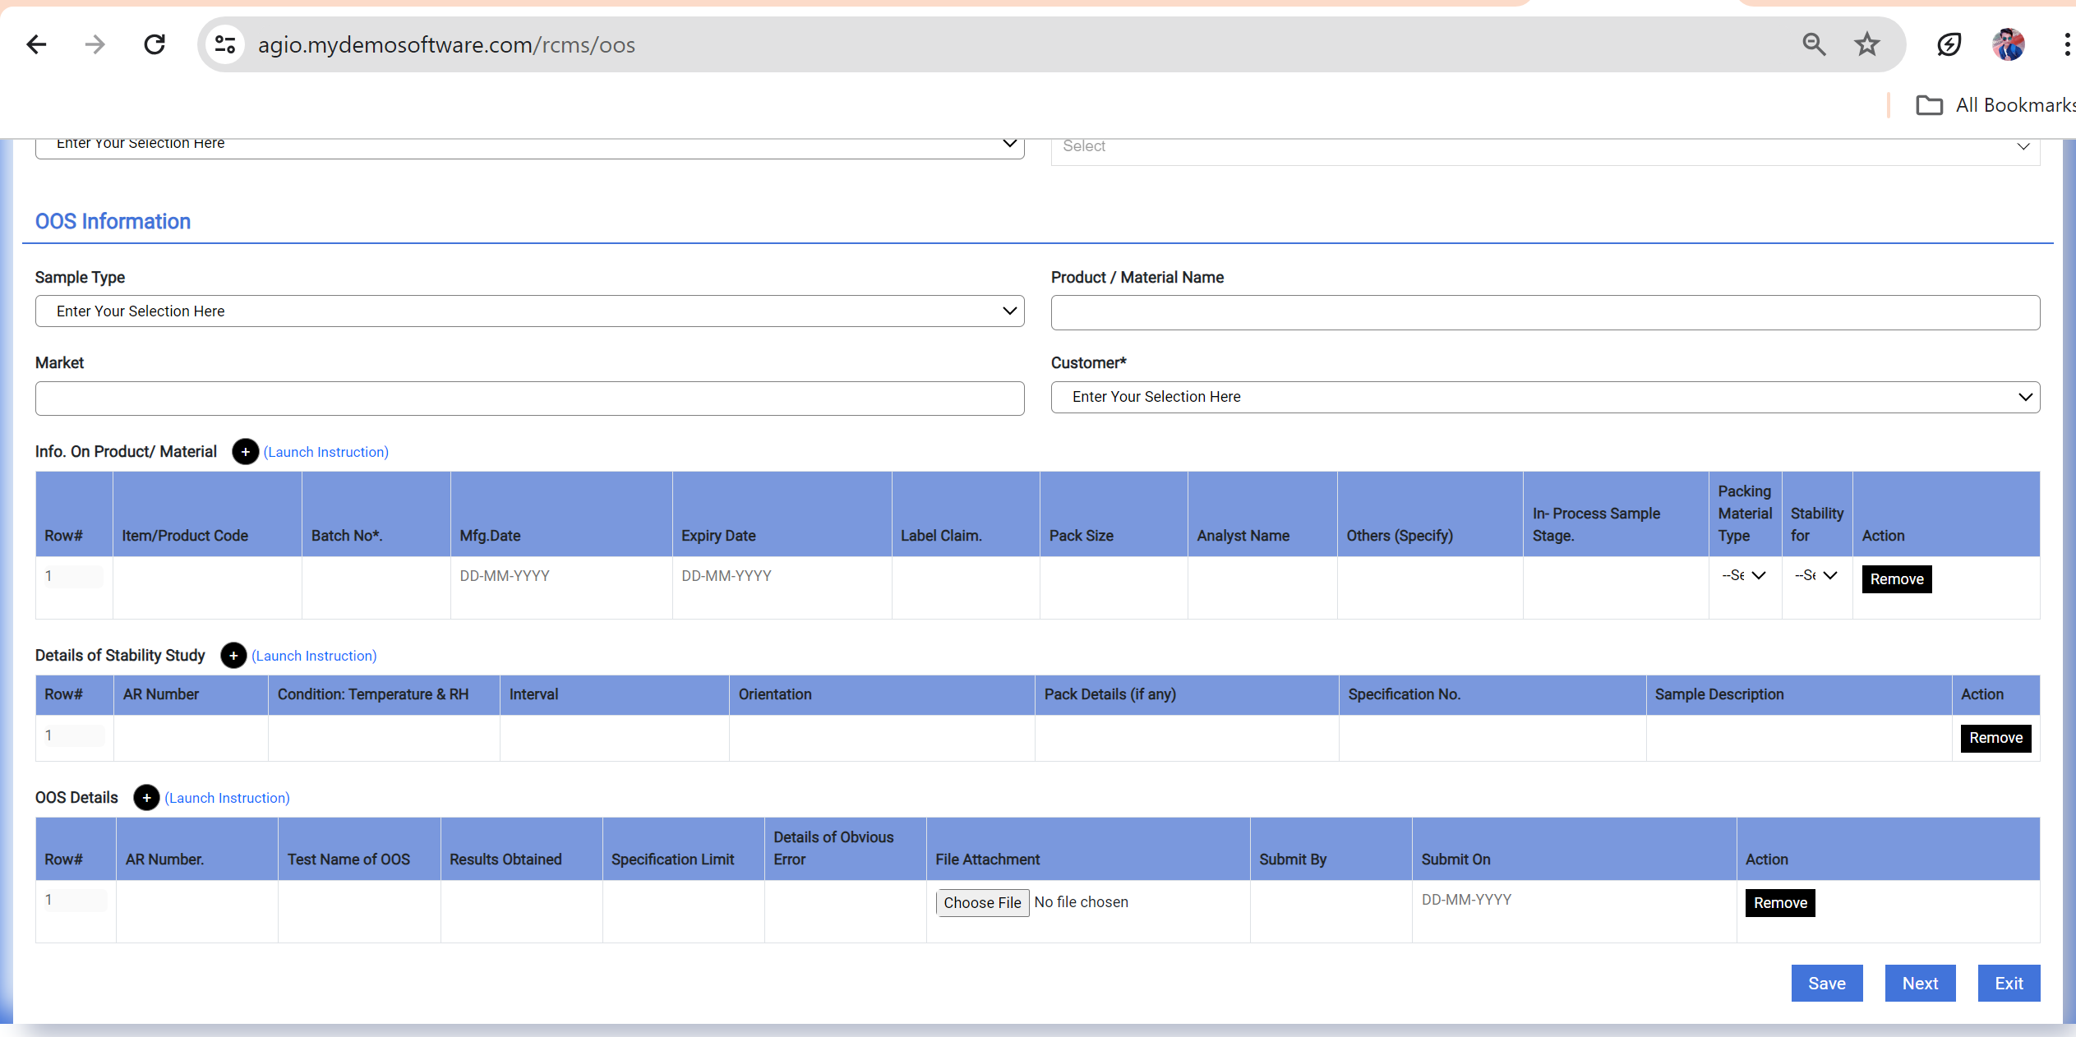

2.In All Other Tab In OOS Chemical Back and next button is not working

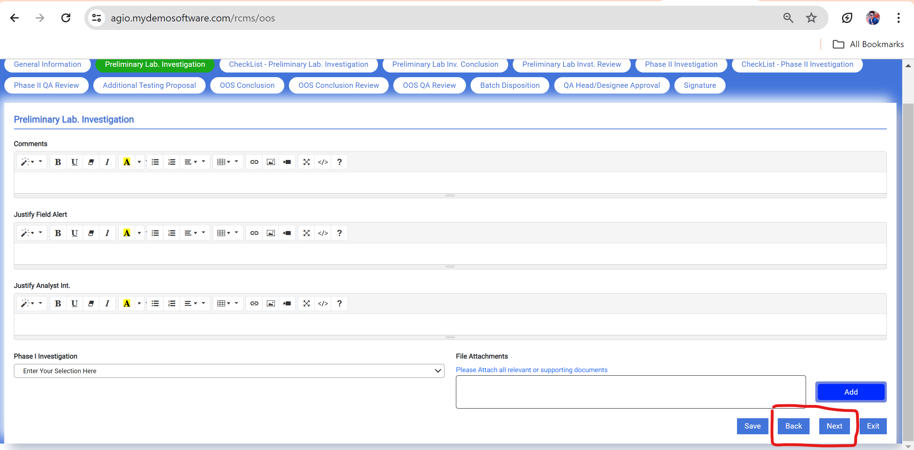

3.Remove this next Button form signature tab from OOS Chemical

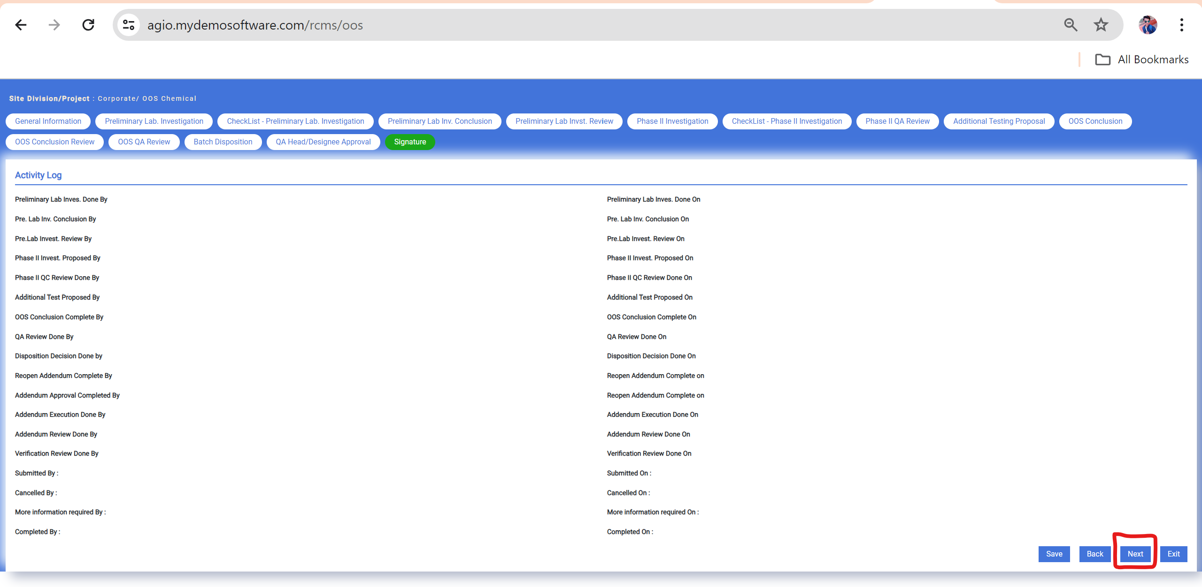

4. Correct The Date Format and Select an option in OOS Review for Similar Nature Grid in Preliminary Lab Invest. Review Tab

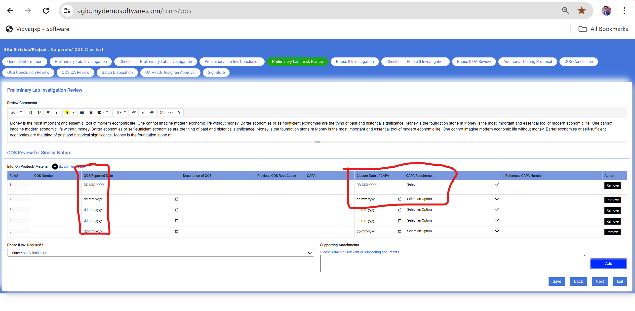

5. Attachment is not added in Phase II Investigation

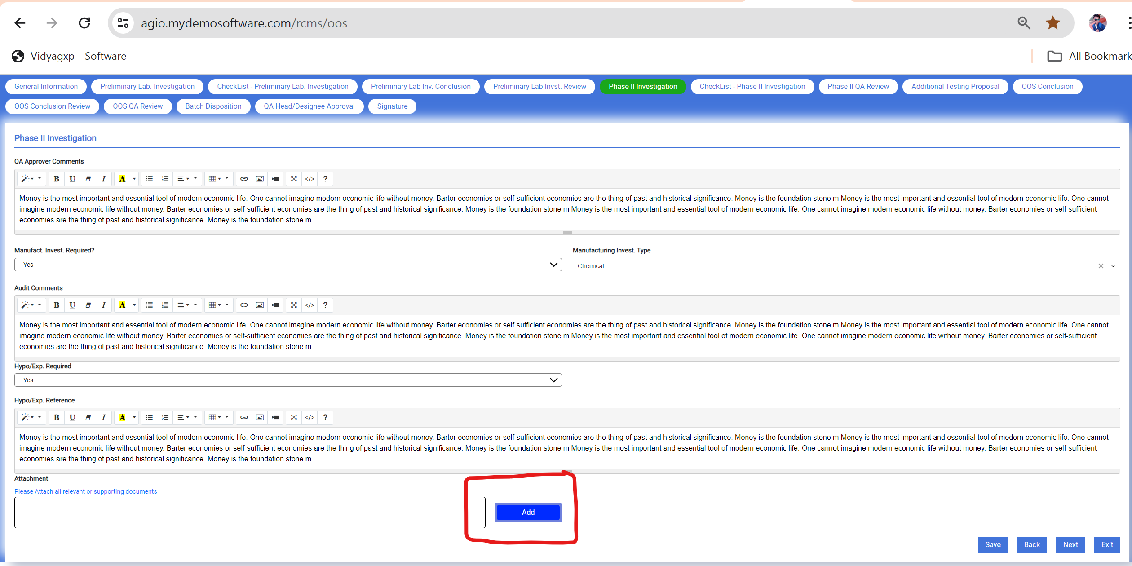

6. After clicking on + button of Summary of OOS Test Result This grid is open like this.

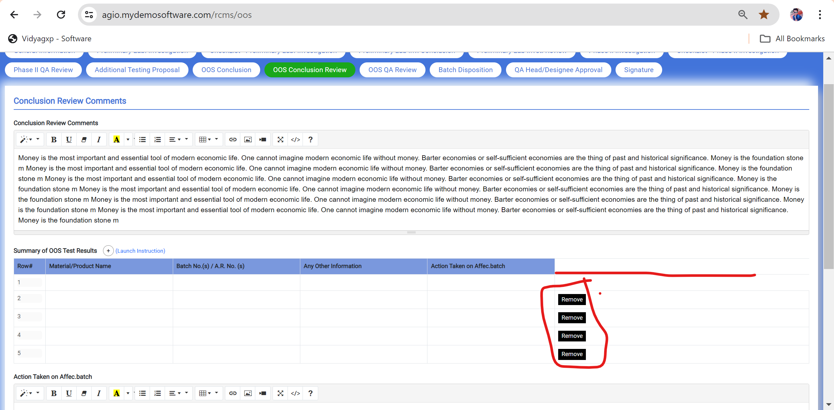

7. Record Number is different from Dashboard When I open Record in Open State

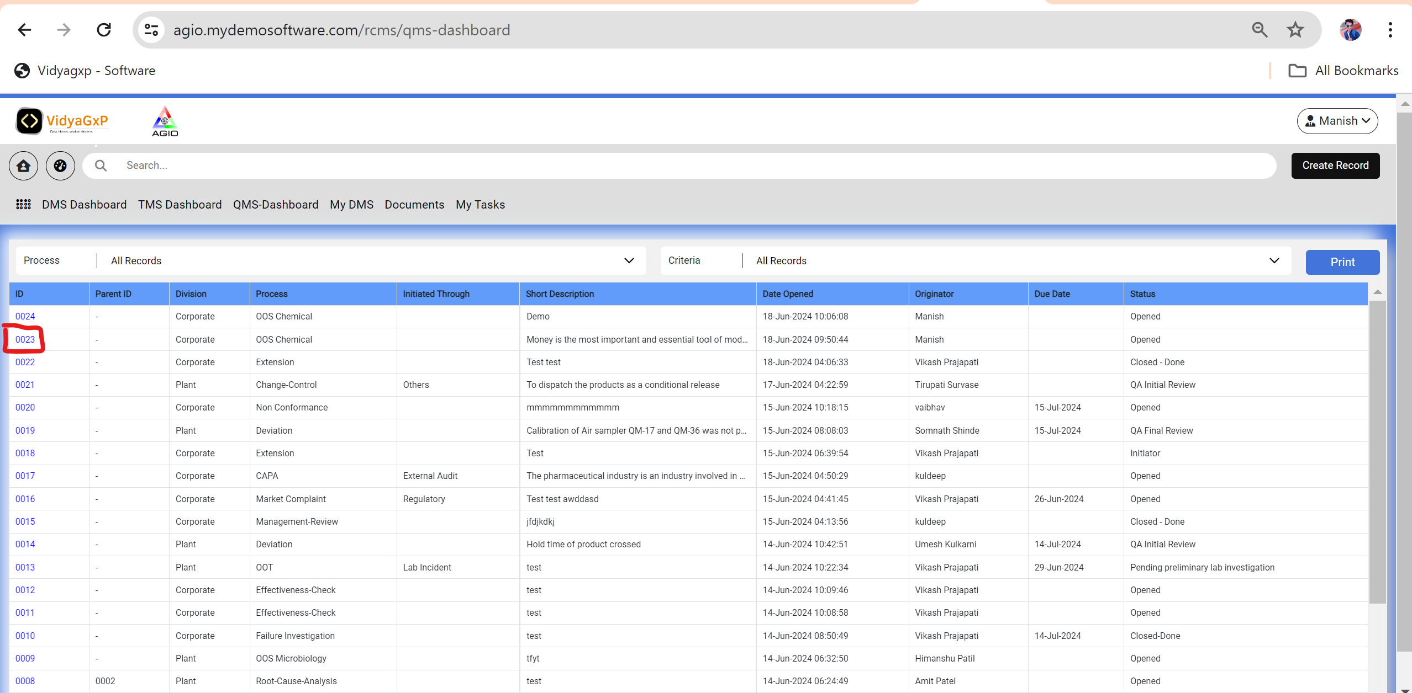

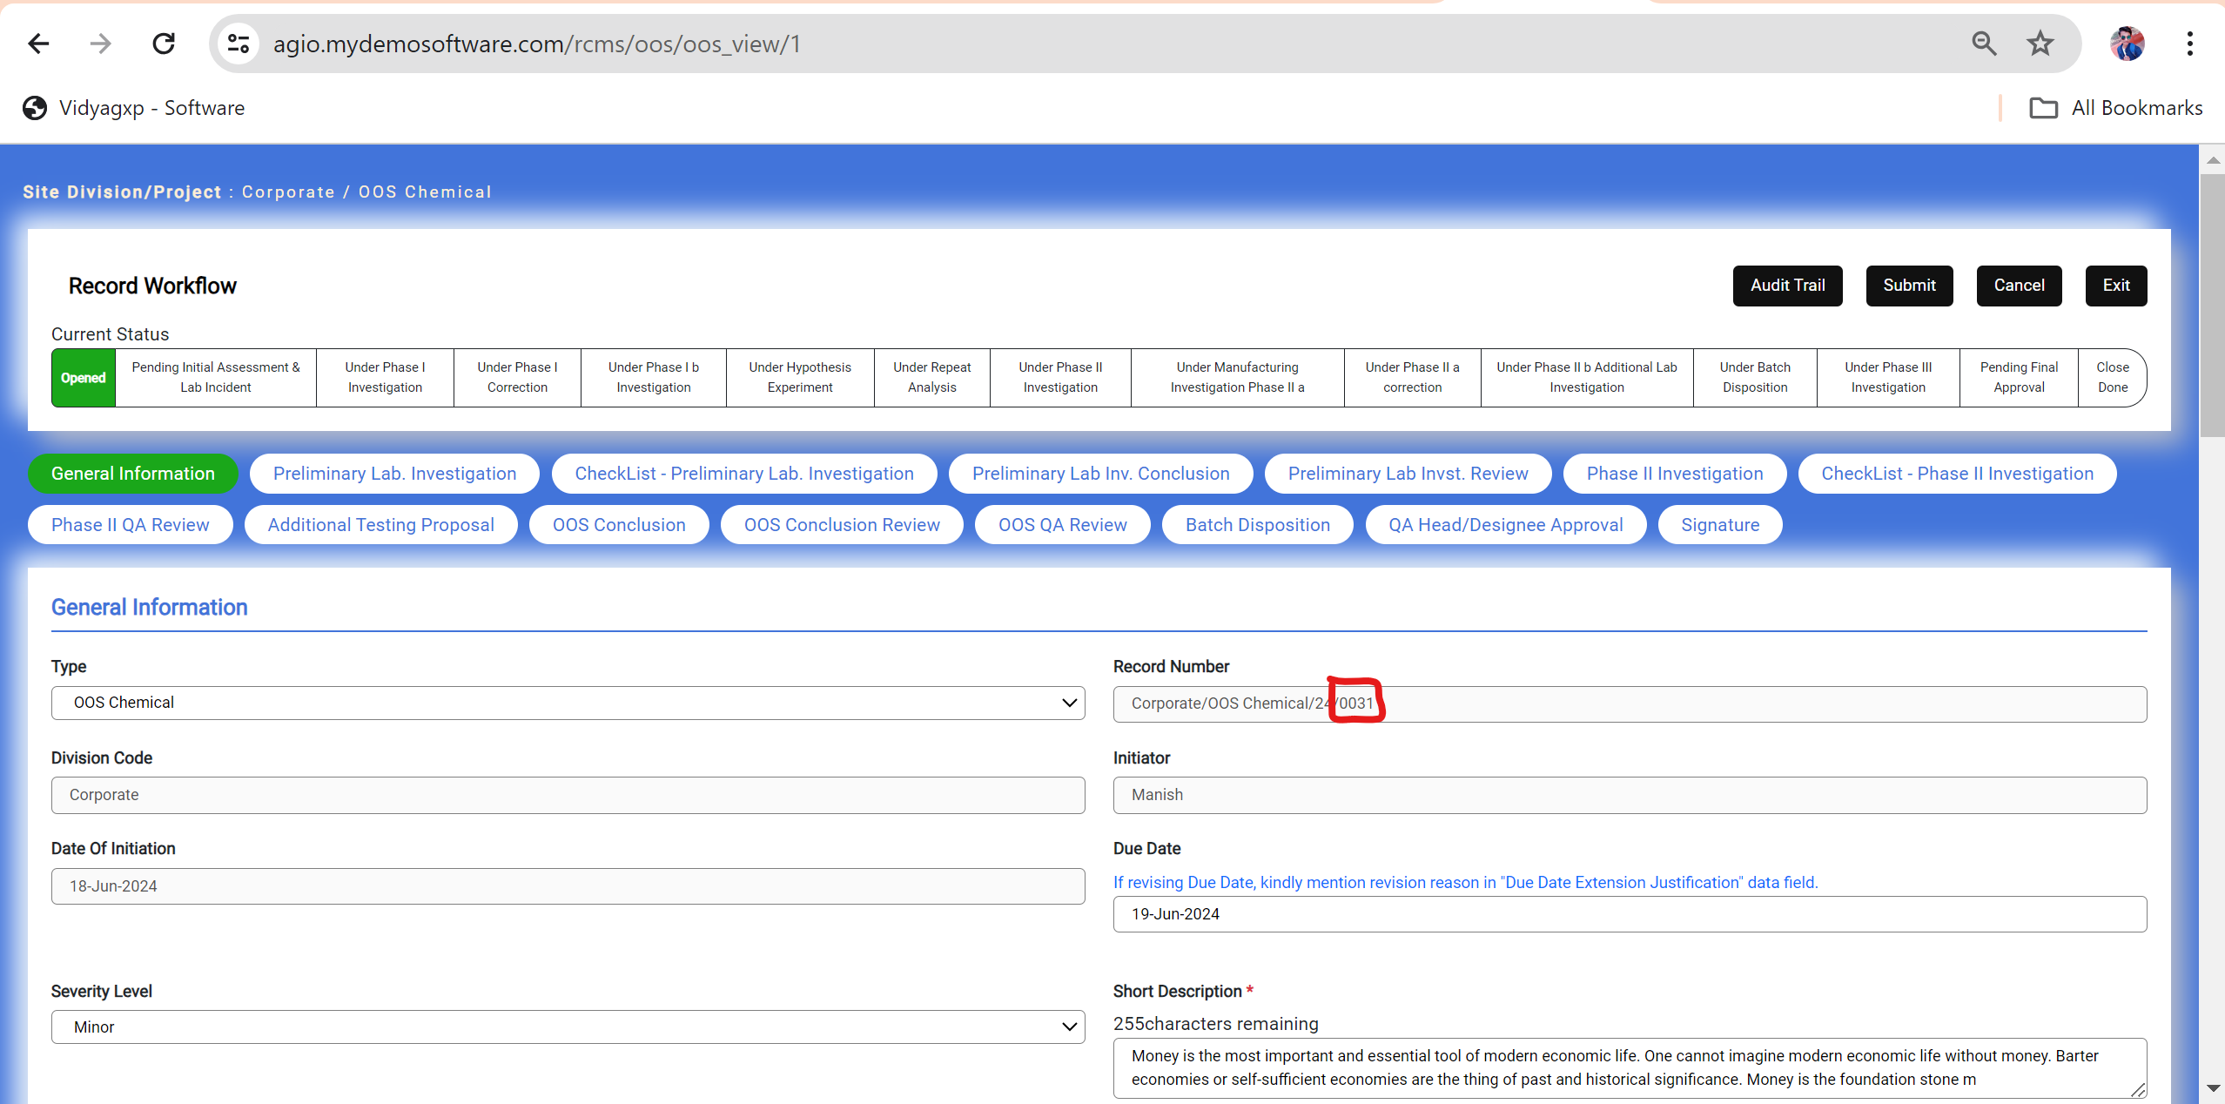

8. Data Vanished in General Information Tab **Source Documentation Type** data field and **Sample Type** Data field.

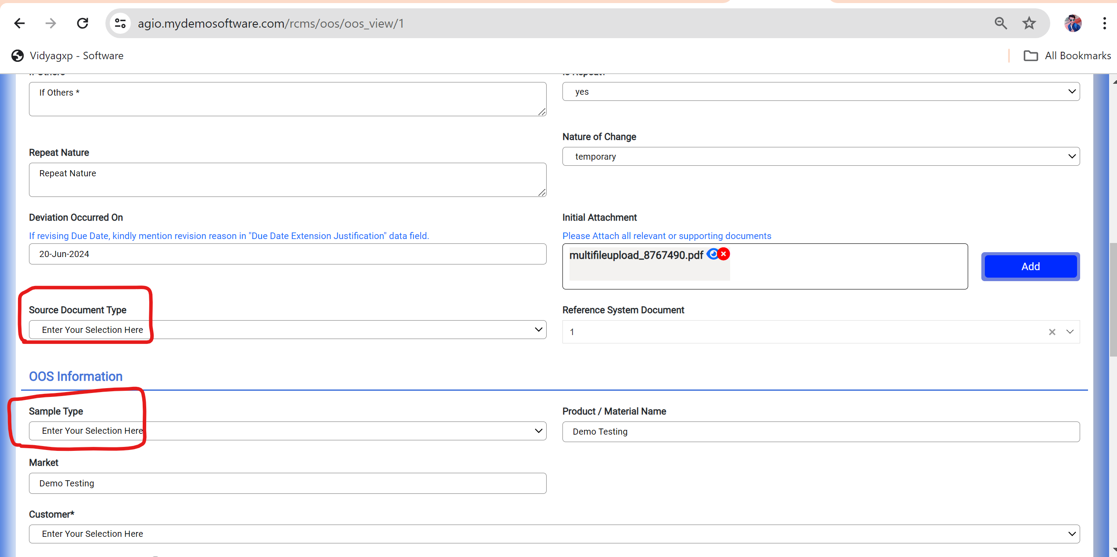

9. Data Vanished in Open State In General Information Tab in OOS-Chemical.

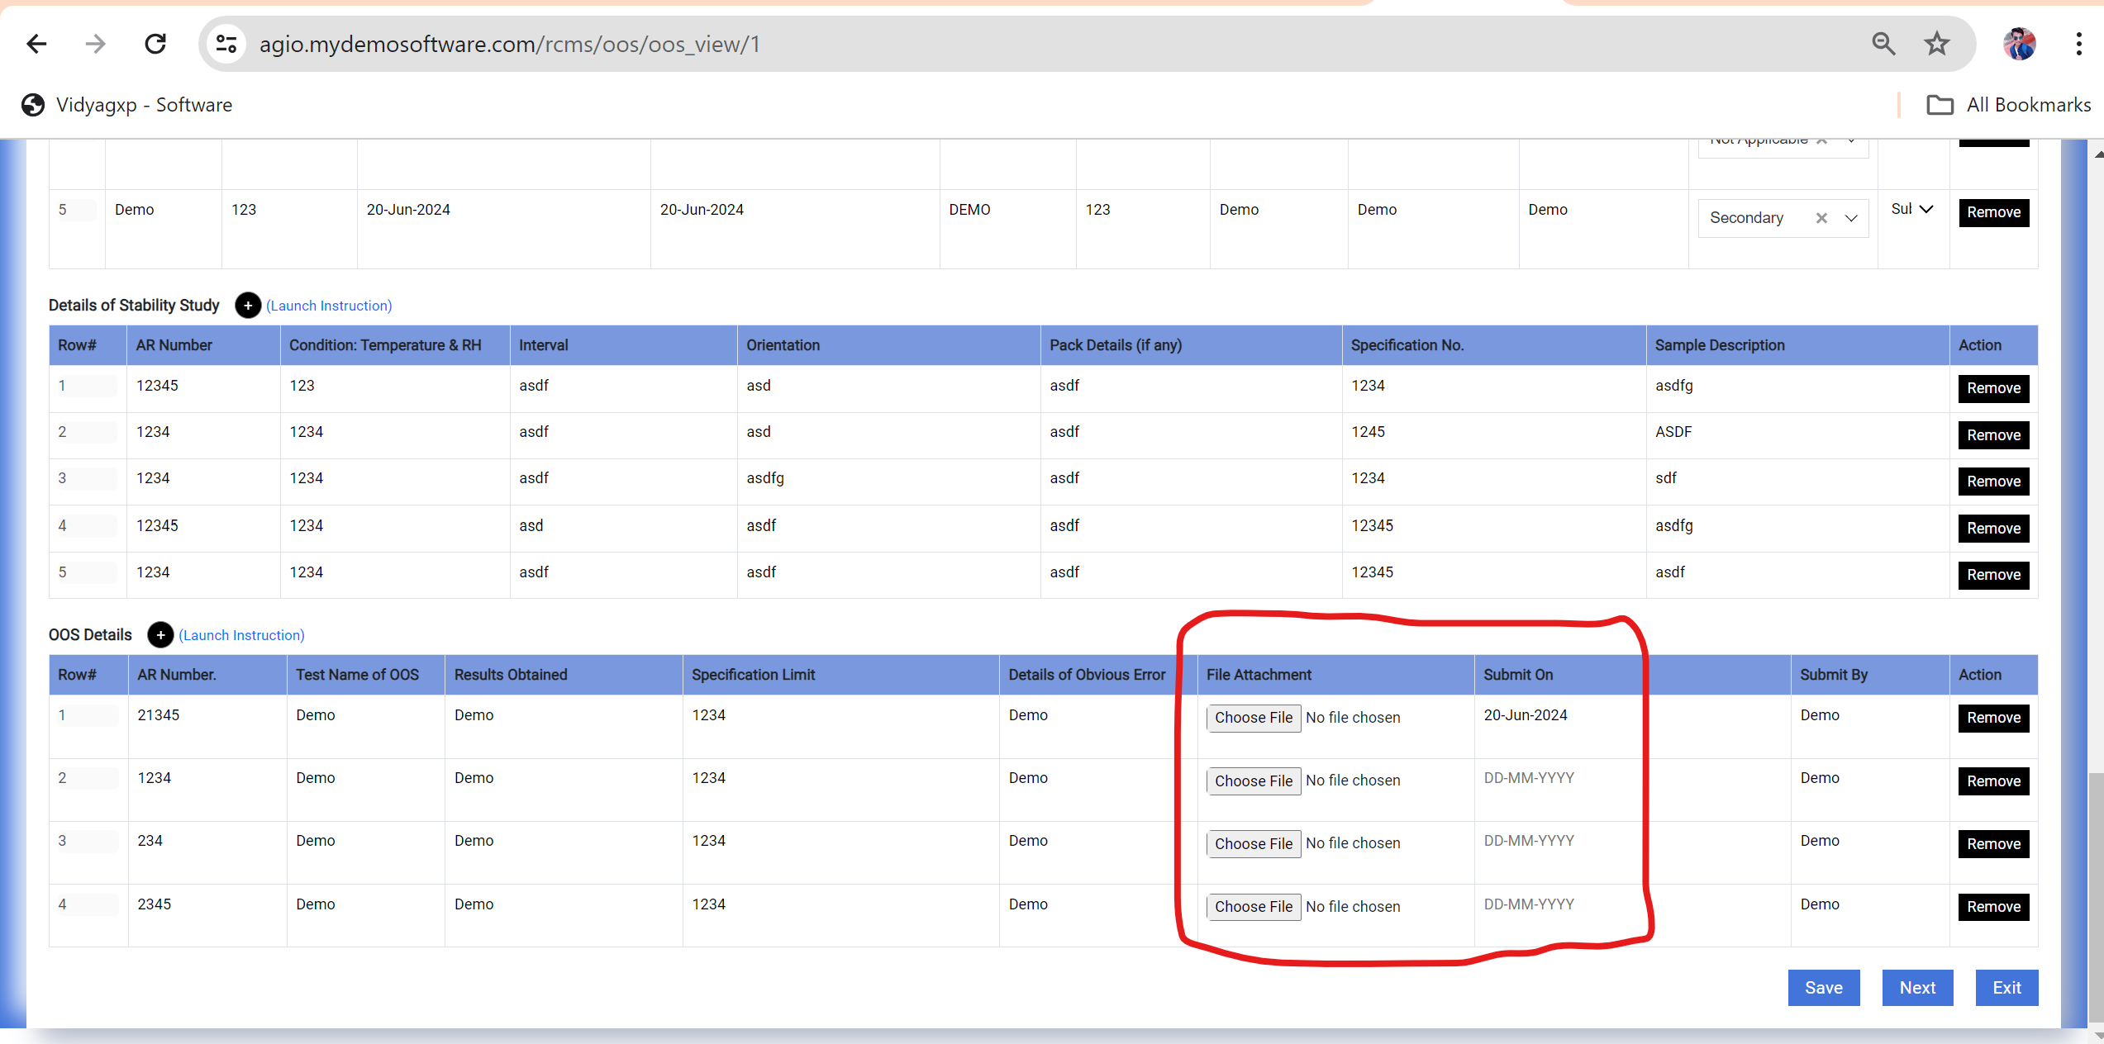

10. Data Vanished in 2nd tab **Phase I Investigation** and I am Adding only 1 file attachment but in open state it shows 2 files.

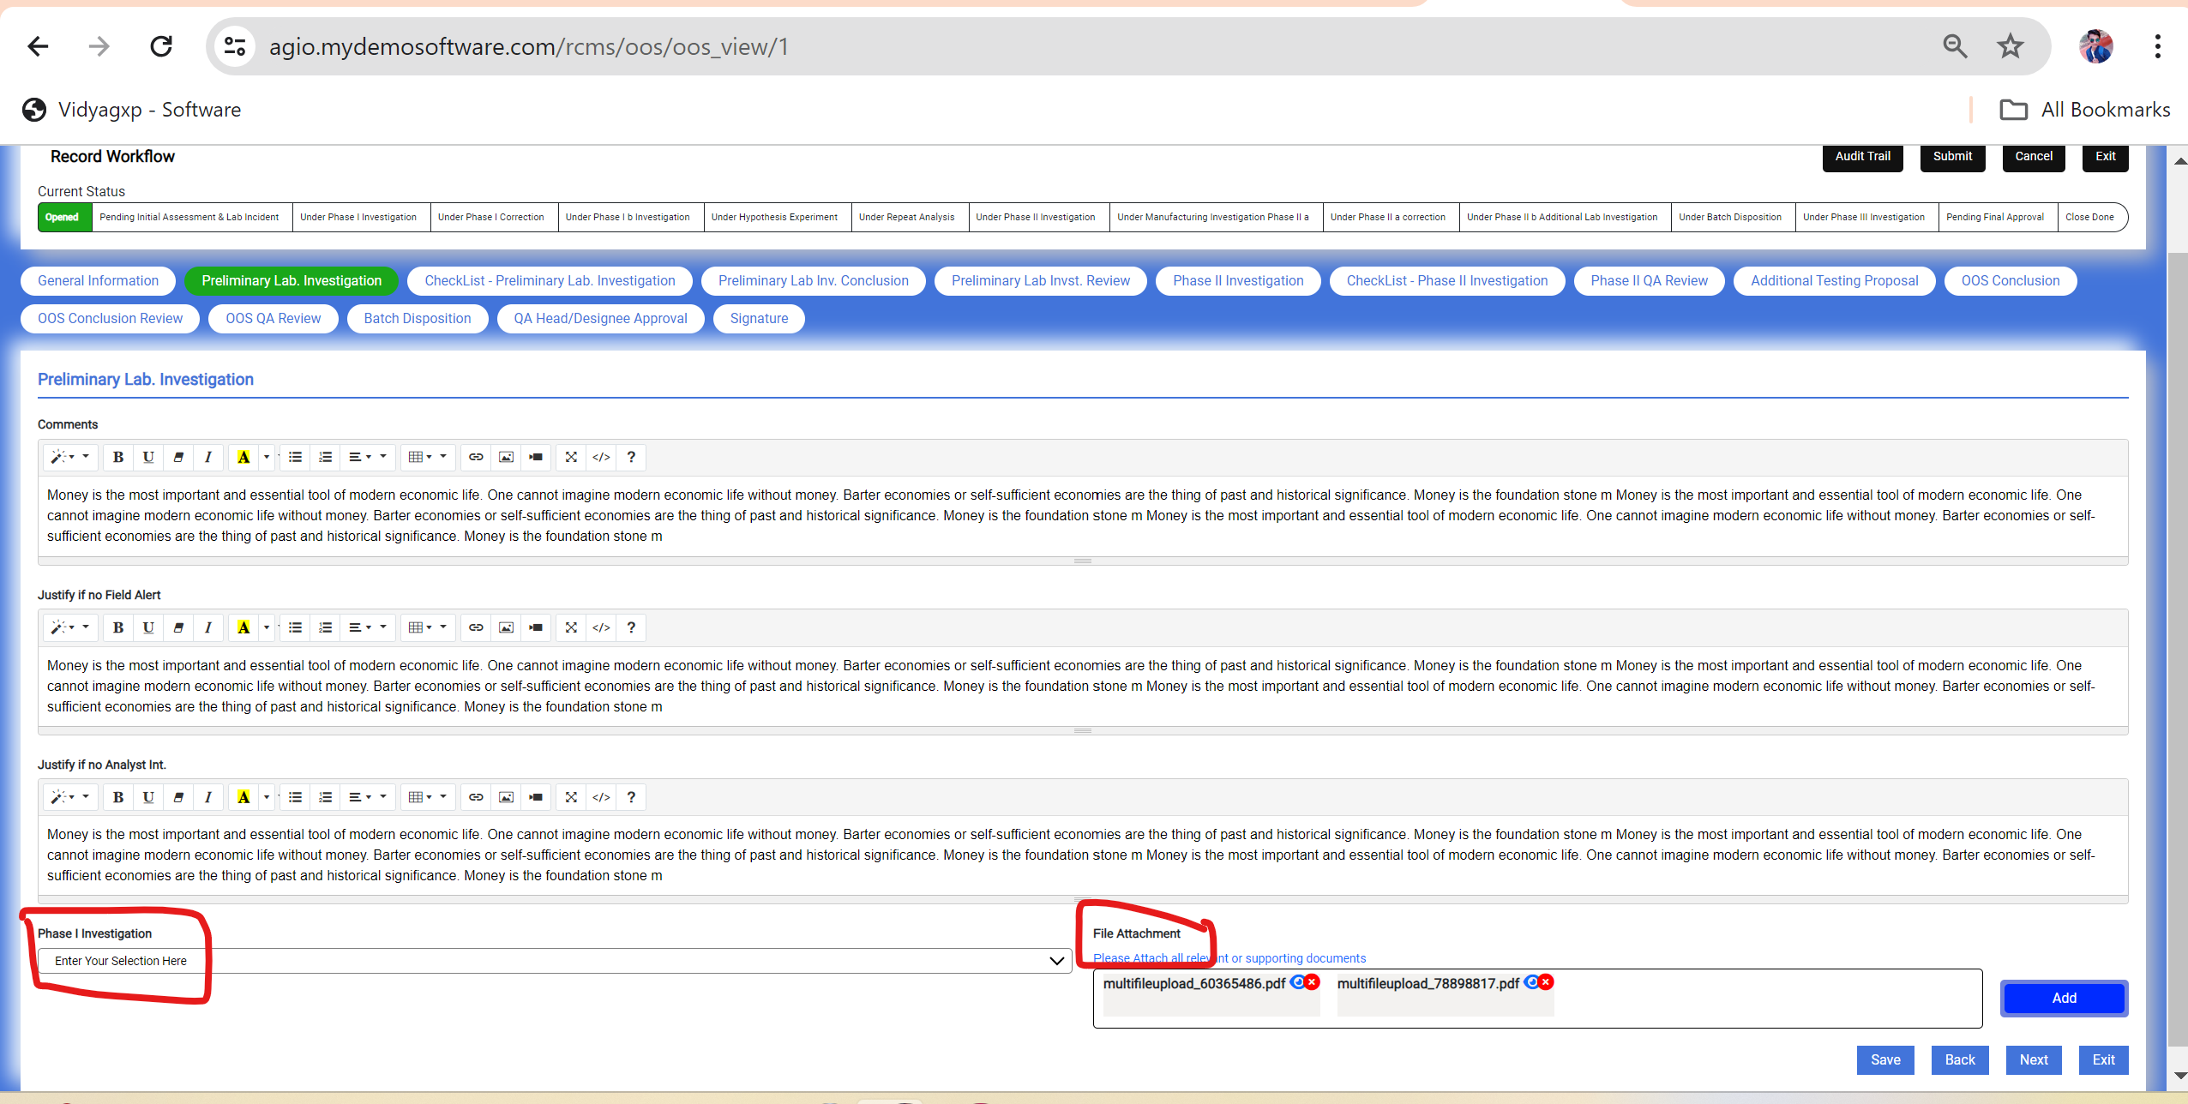

11. Data Vanished in 4th tab **OOS Category Root Couse Ident**. Data field.

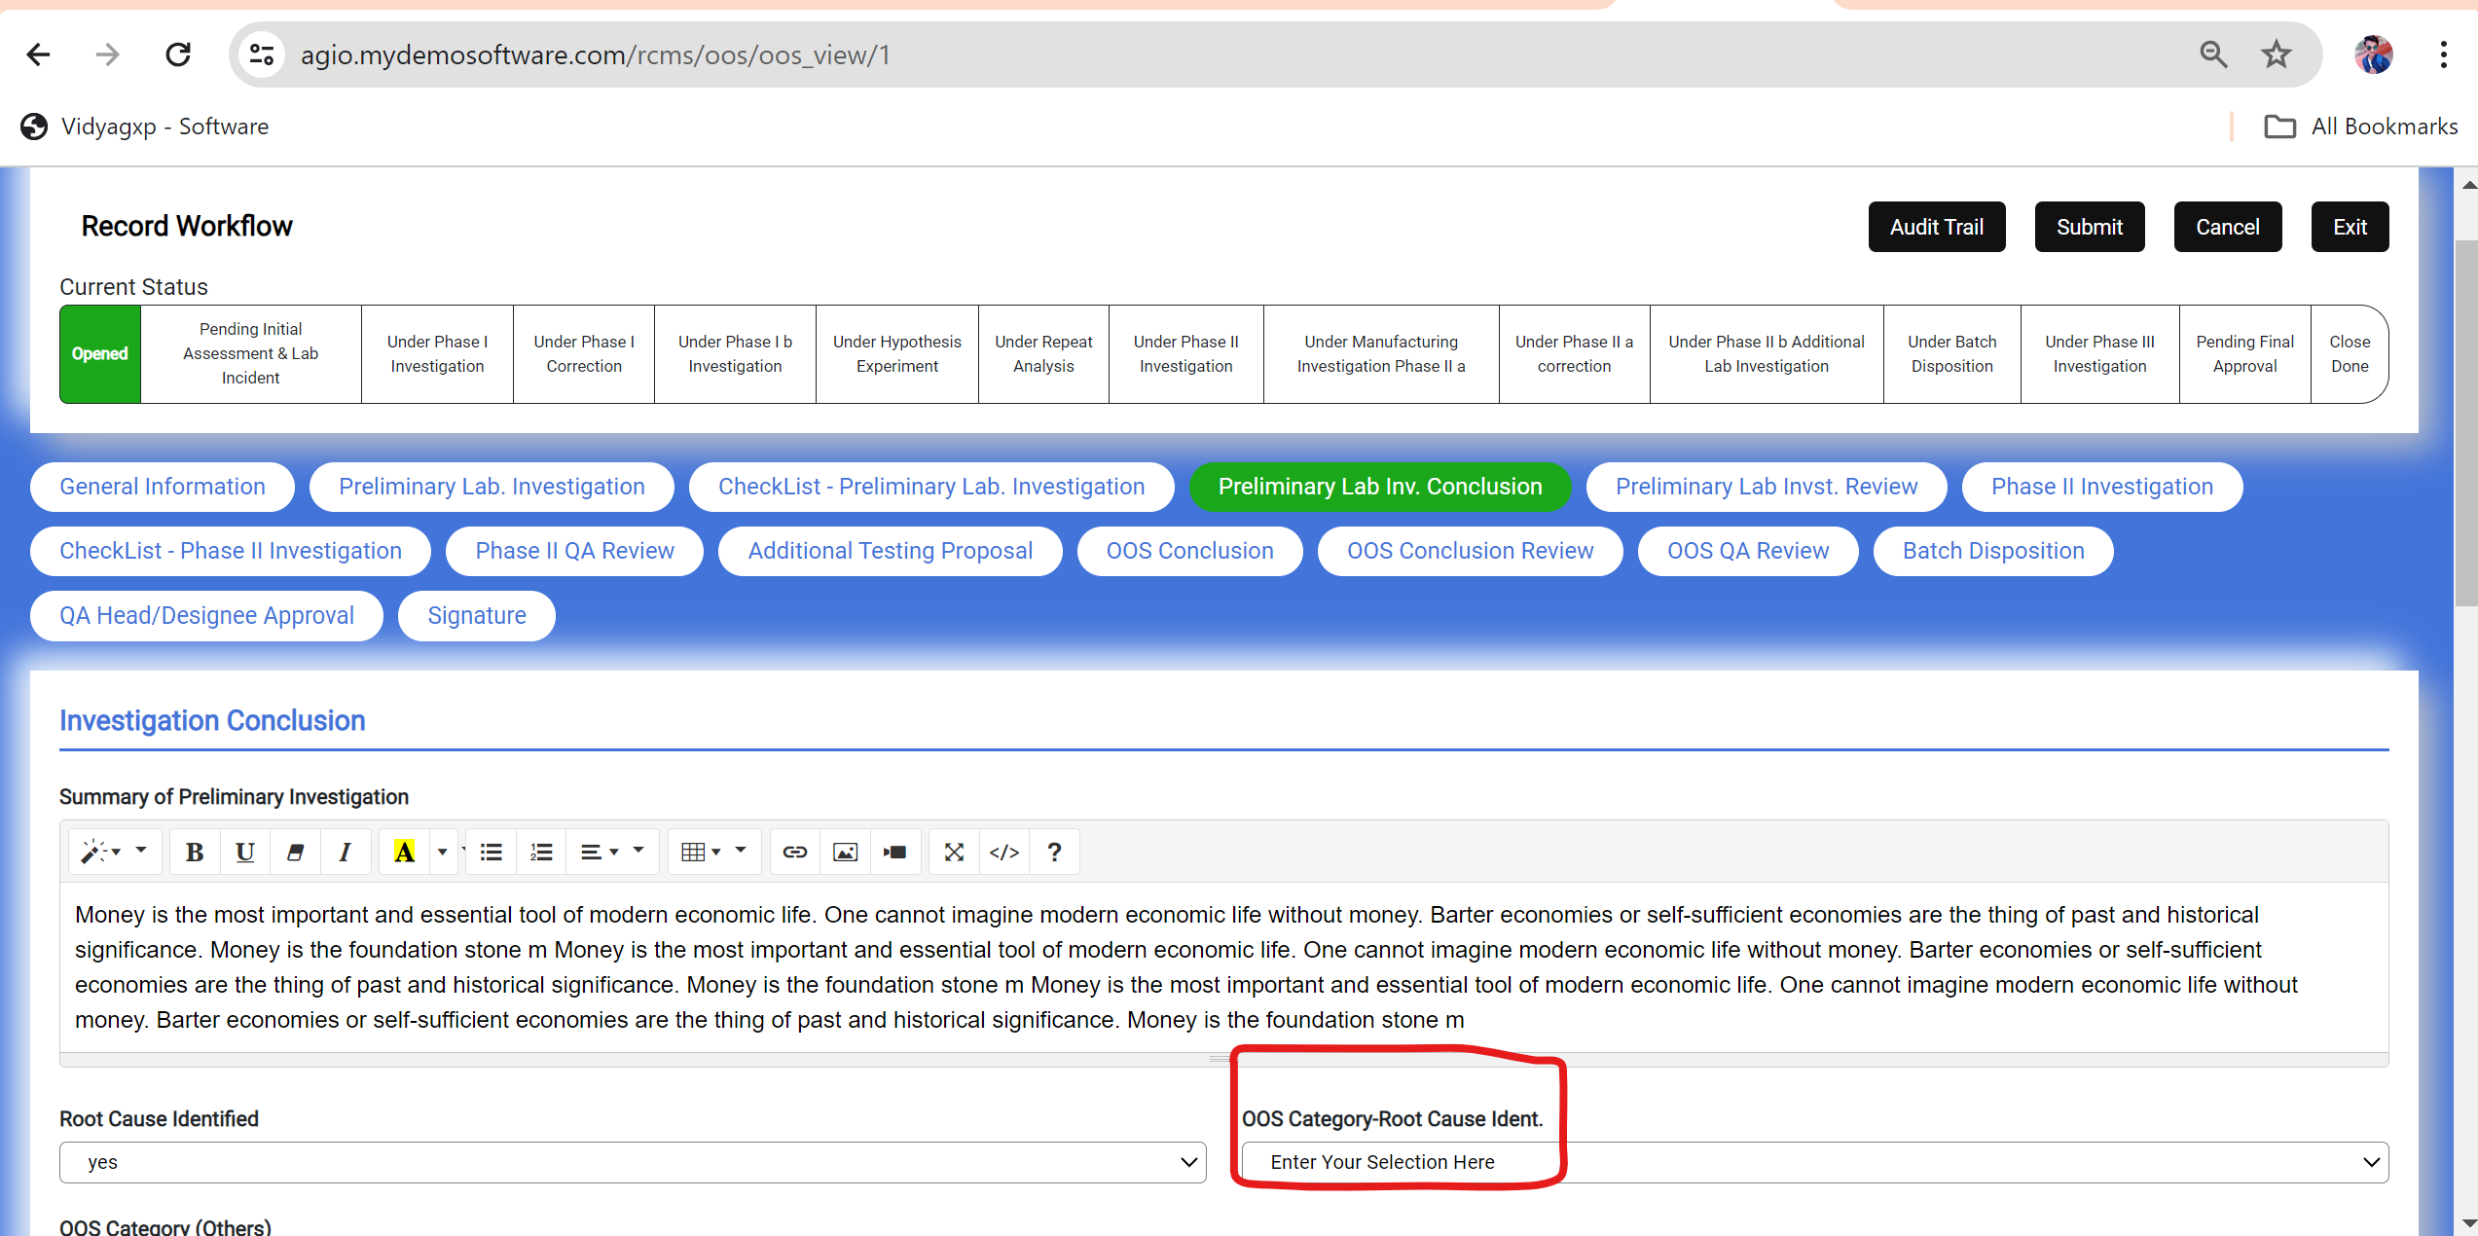

12 Data Vanished in 6th tab **Manufacturing Invest. Type** Data field.

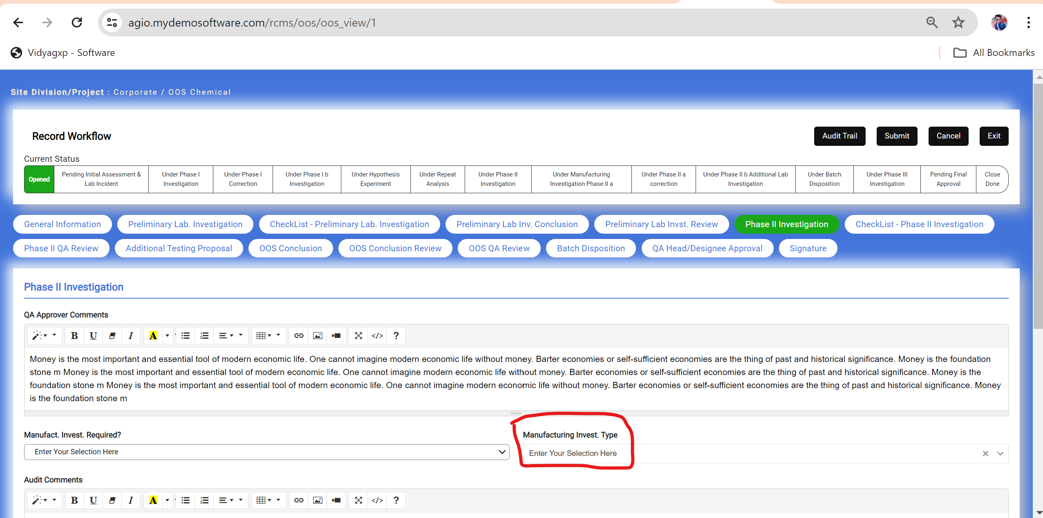

13.Data Vanished in 8th OOS Category Reason Identification Data Field.

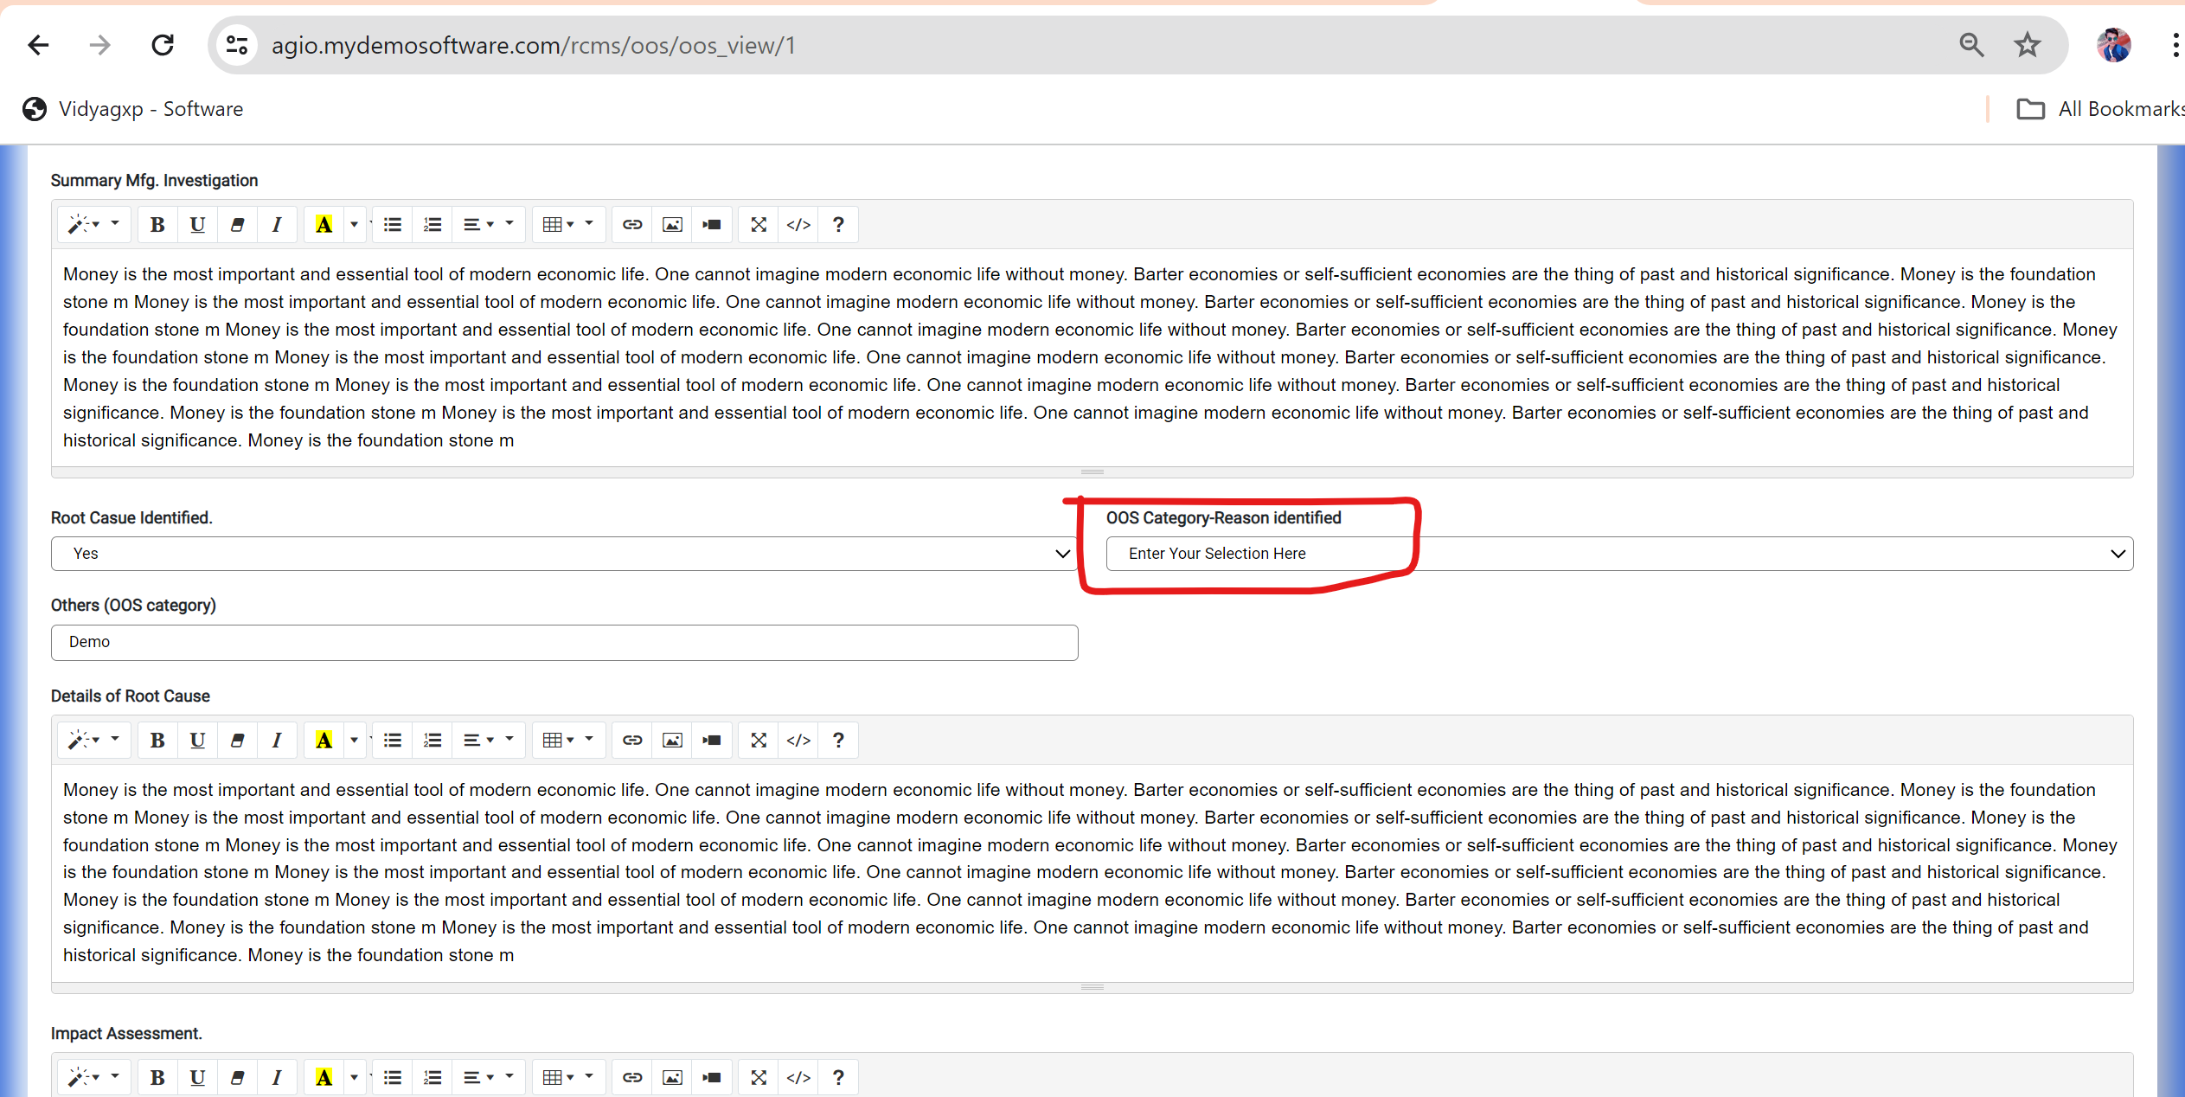

14.Data Vanished in 10th Tab **Results to be reported** data field.

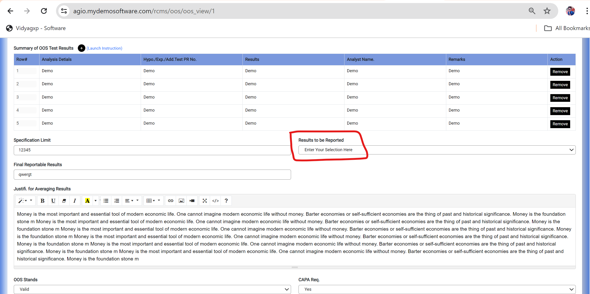

15.When I Am Creating CAPA Child effectiveness check record is open in Pending Initial Assessment & lab Incident state.

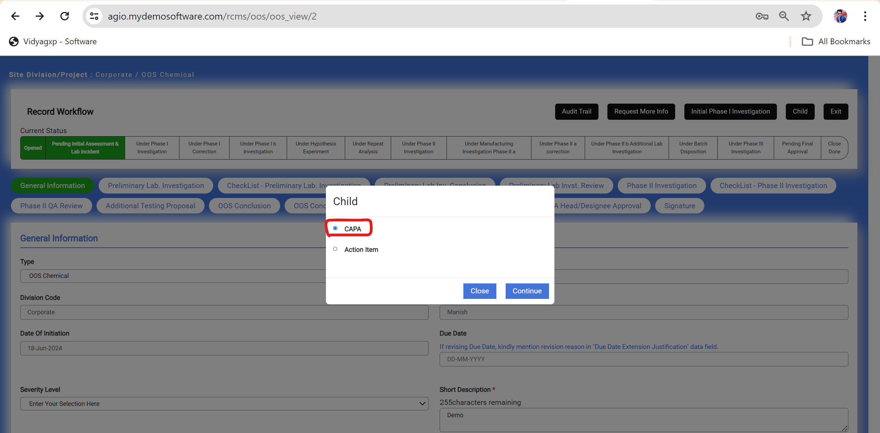

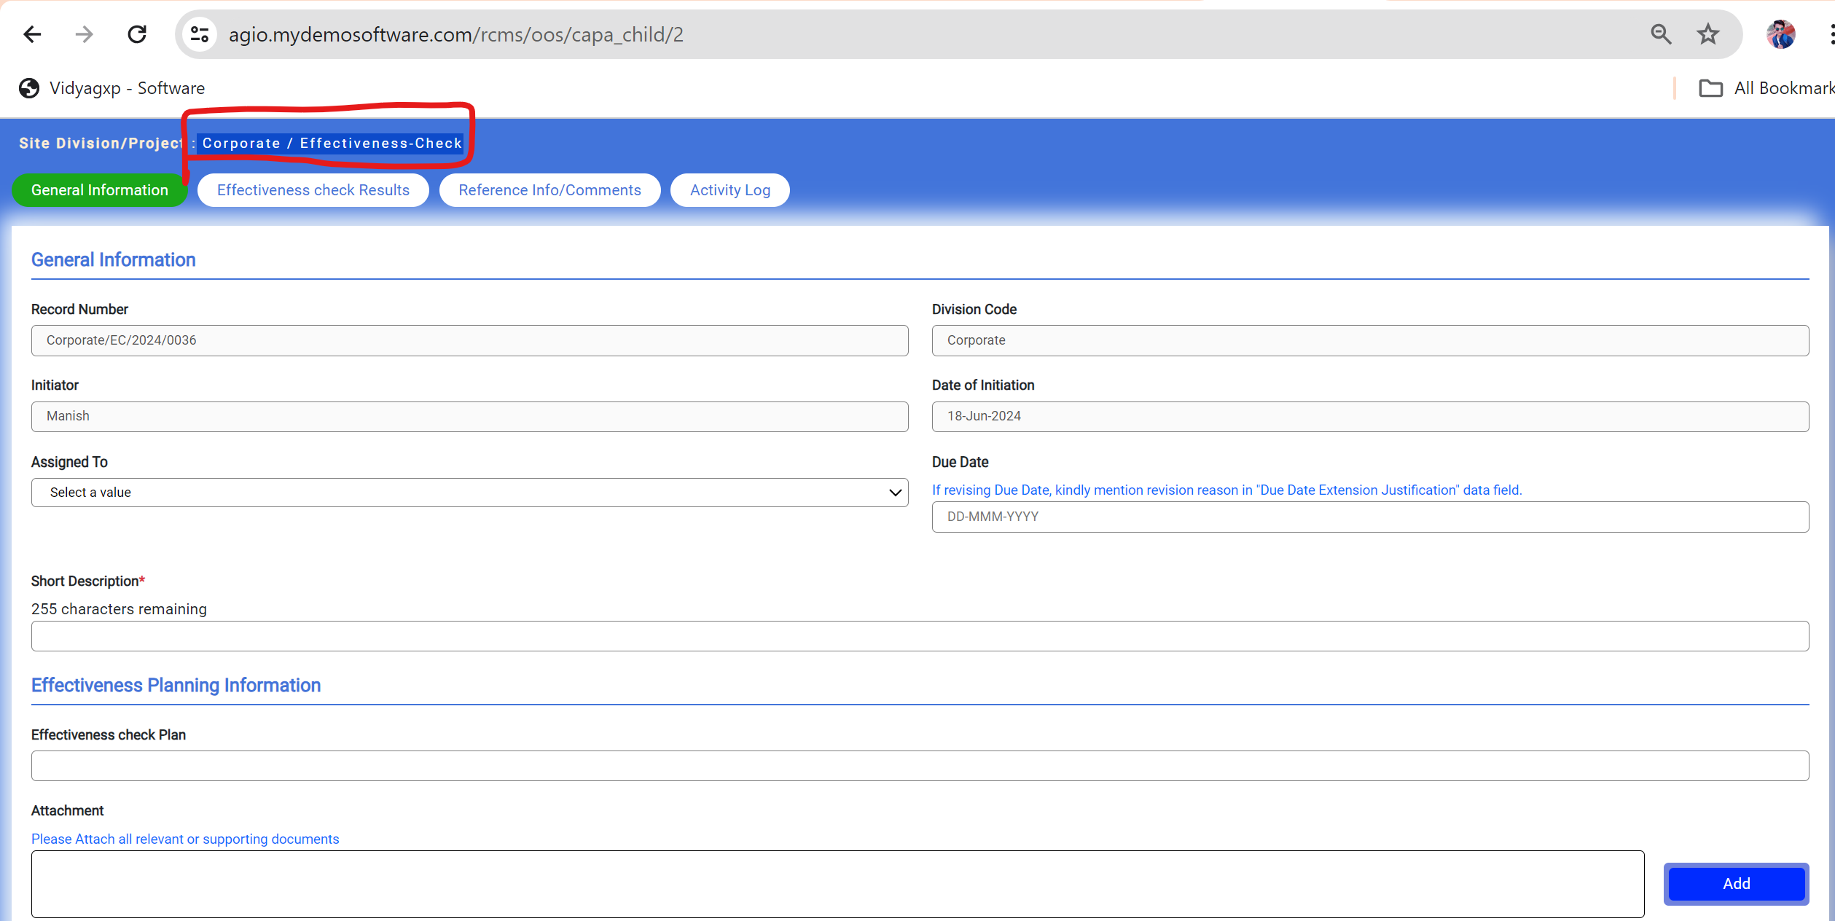

16. When I am creating Action Item child in Pending Initial Assessment & Lab Incident State it show me error.

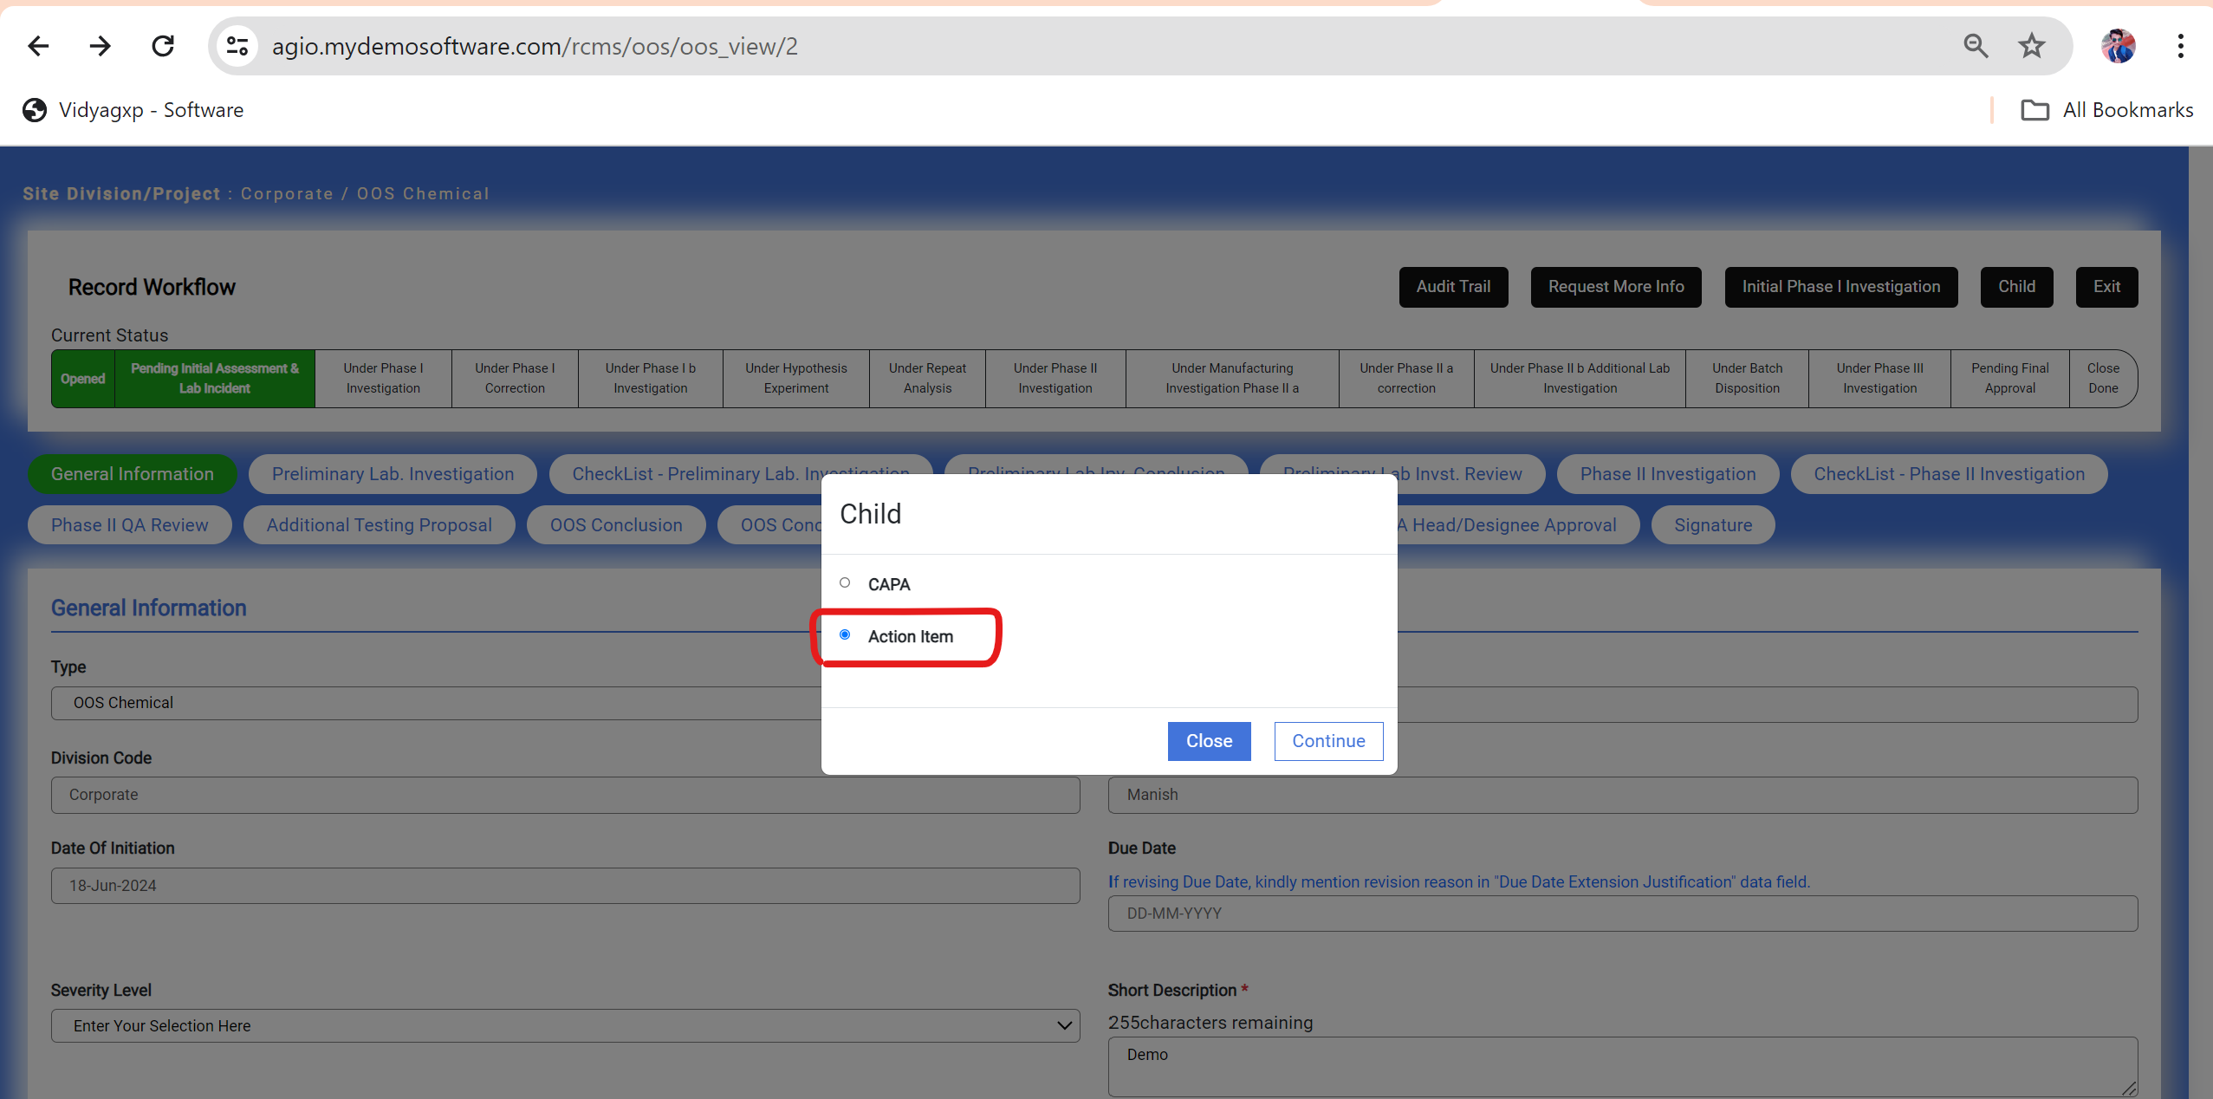

Error

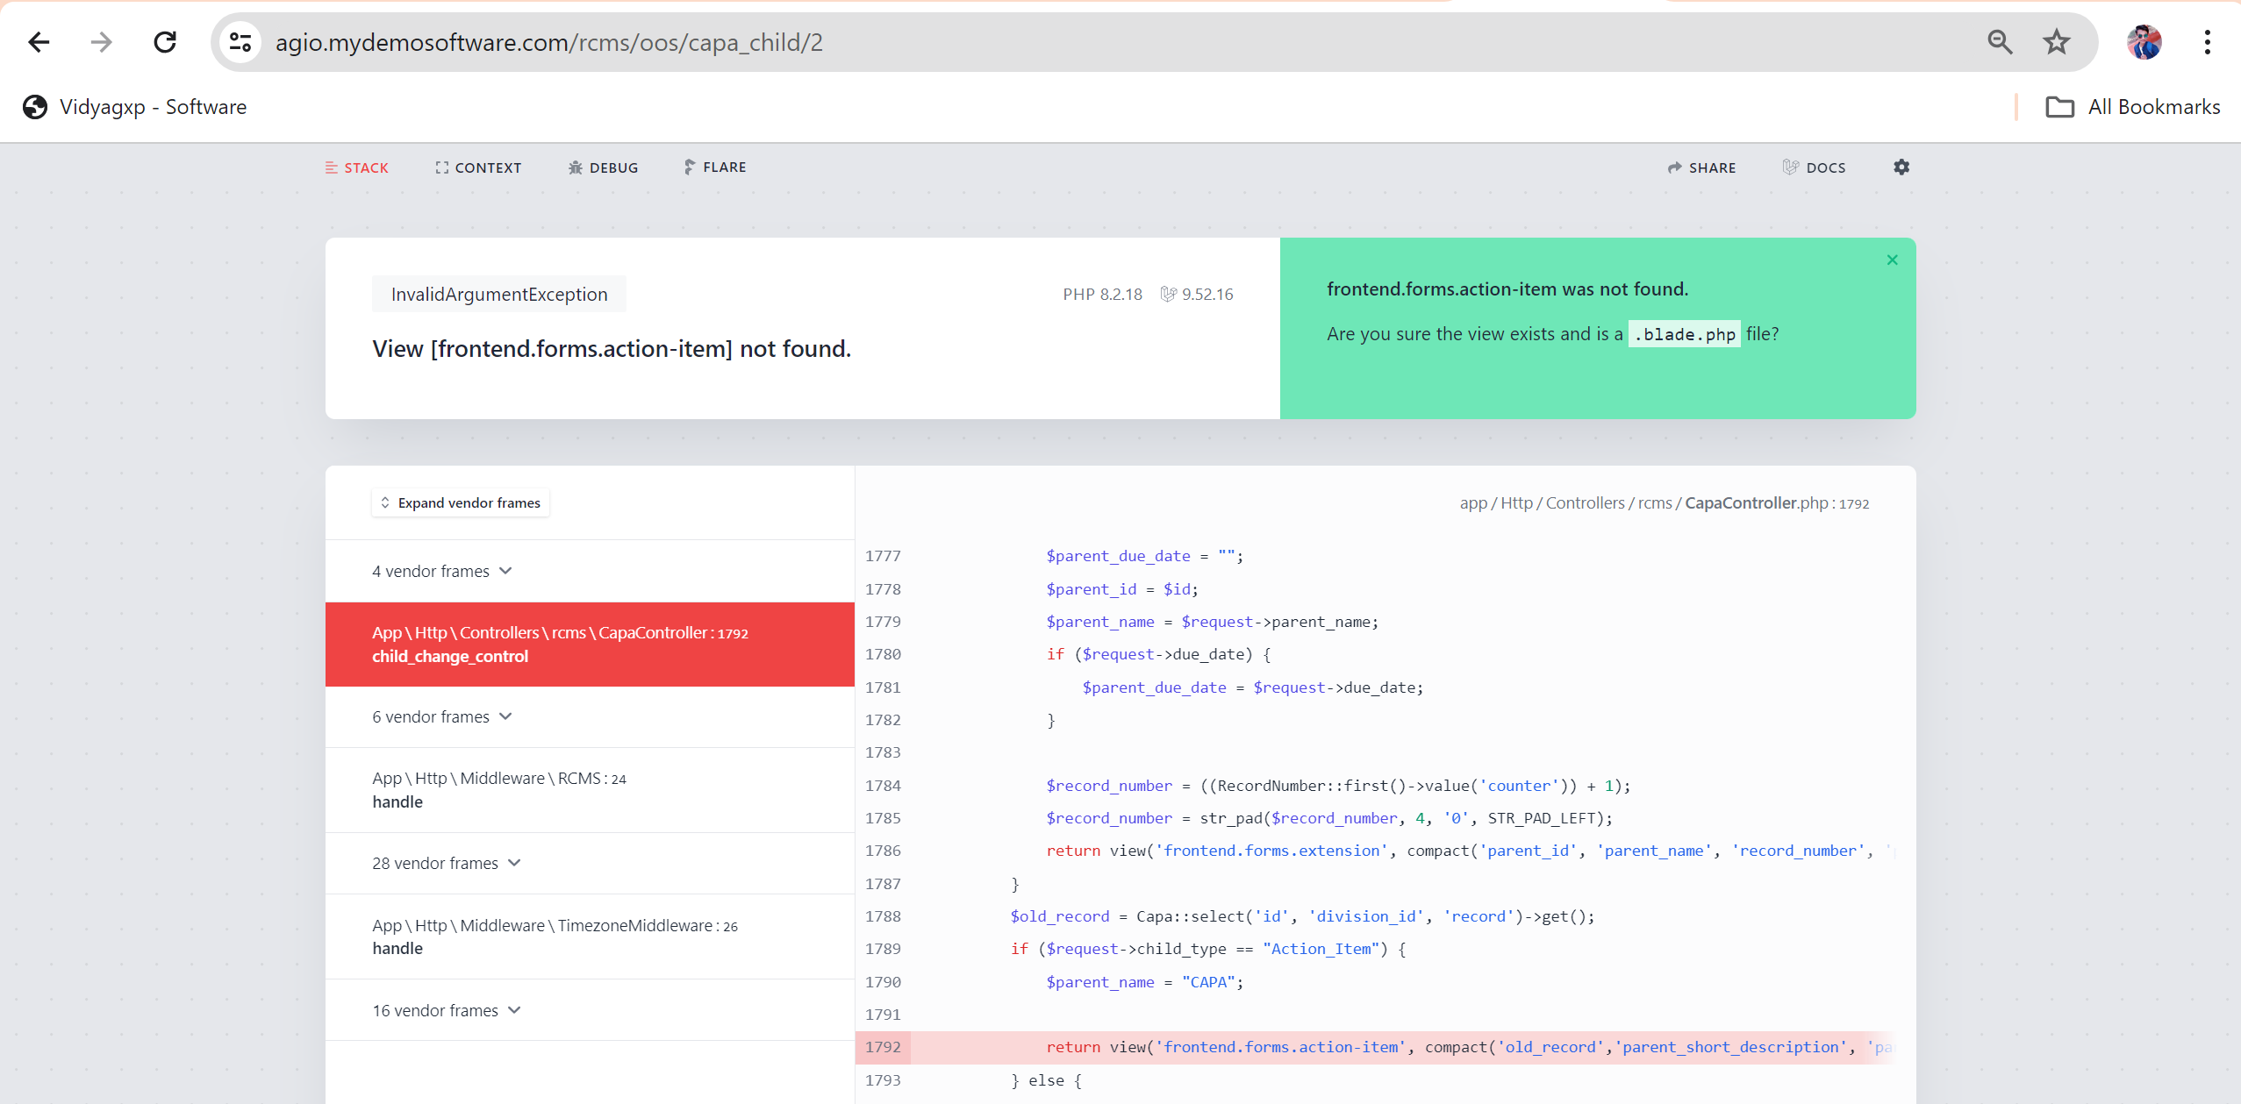

Note: Please Check All Child Buttons in this Record According to Workflow.

Child are not working proper in every state according to workflow.

17. In Request More info Comment Data field is mandatory to fill.

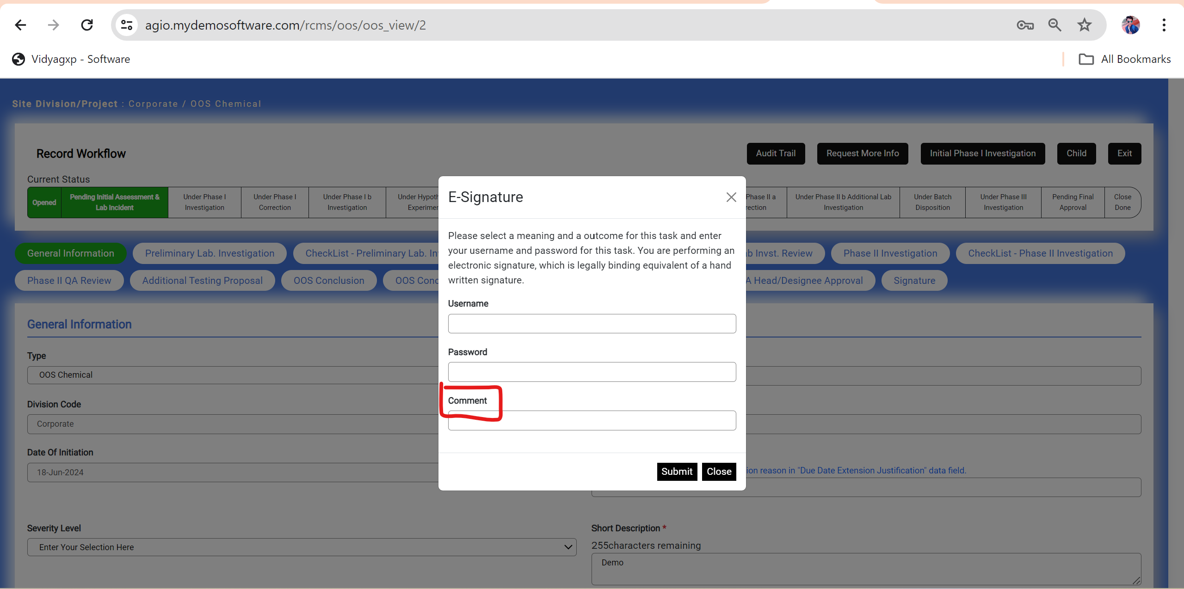

18. In Under Phase I investigation State Request more info activity Comment Data field is mandatory.

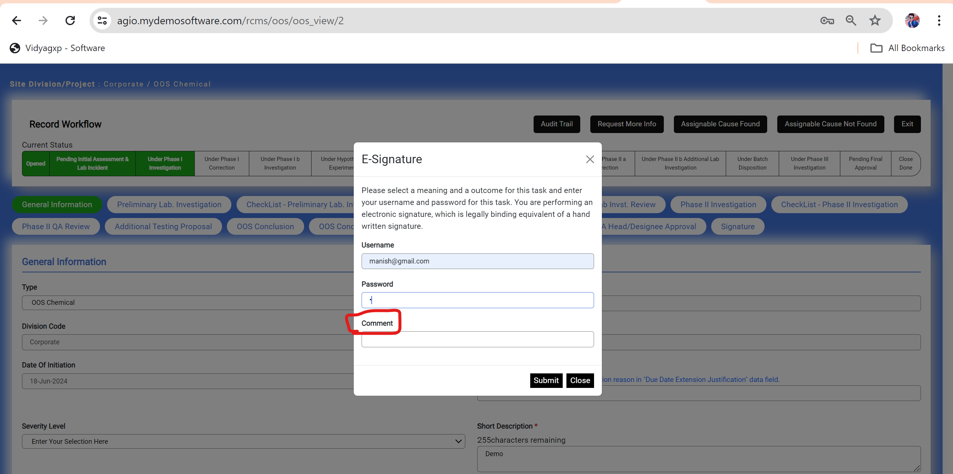

Note: And Also check all Return Activity Comment data field is required like Request More Info.

19.Under Hypothesis Experiment State Only 1 child Action Item is created. Remove CAPA as a child from here.

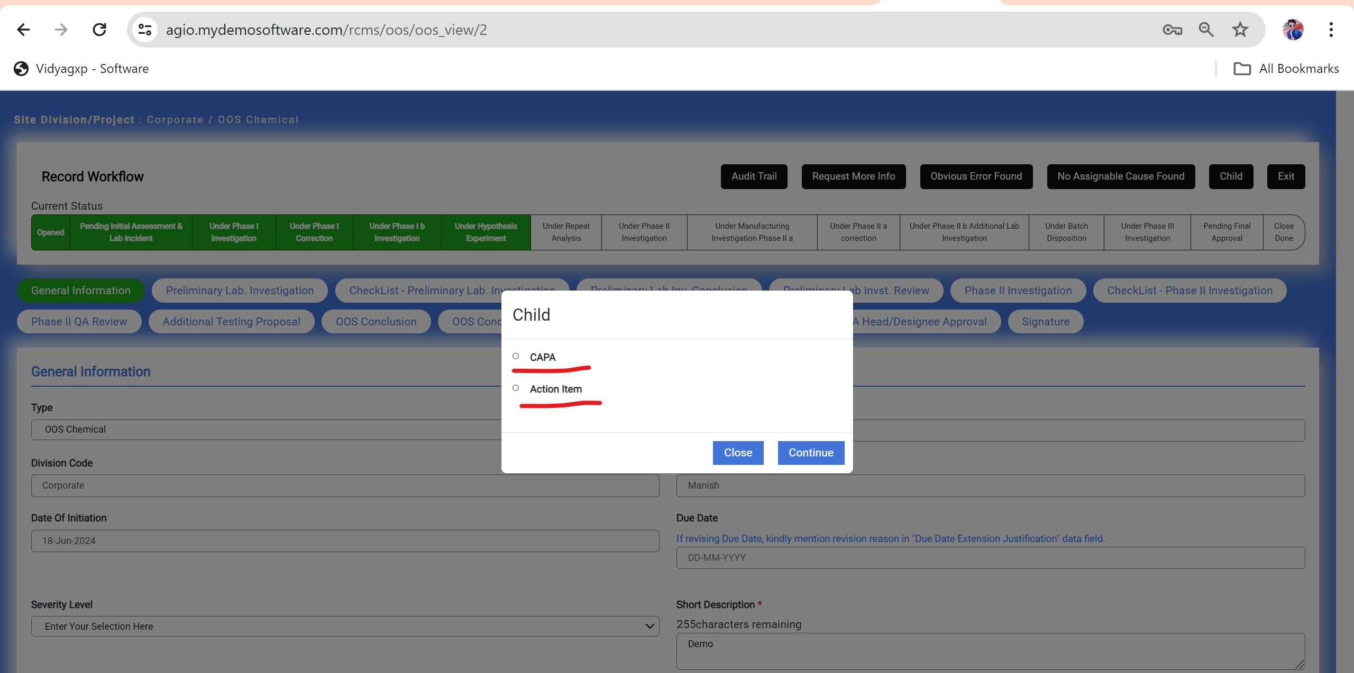

20. After performing this Phase II Correction Inconclusive Activity this blank page is Show.

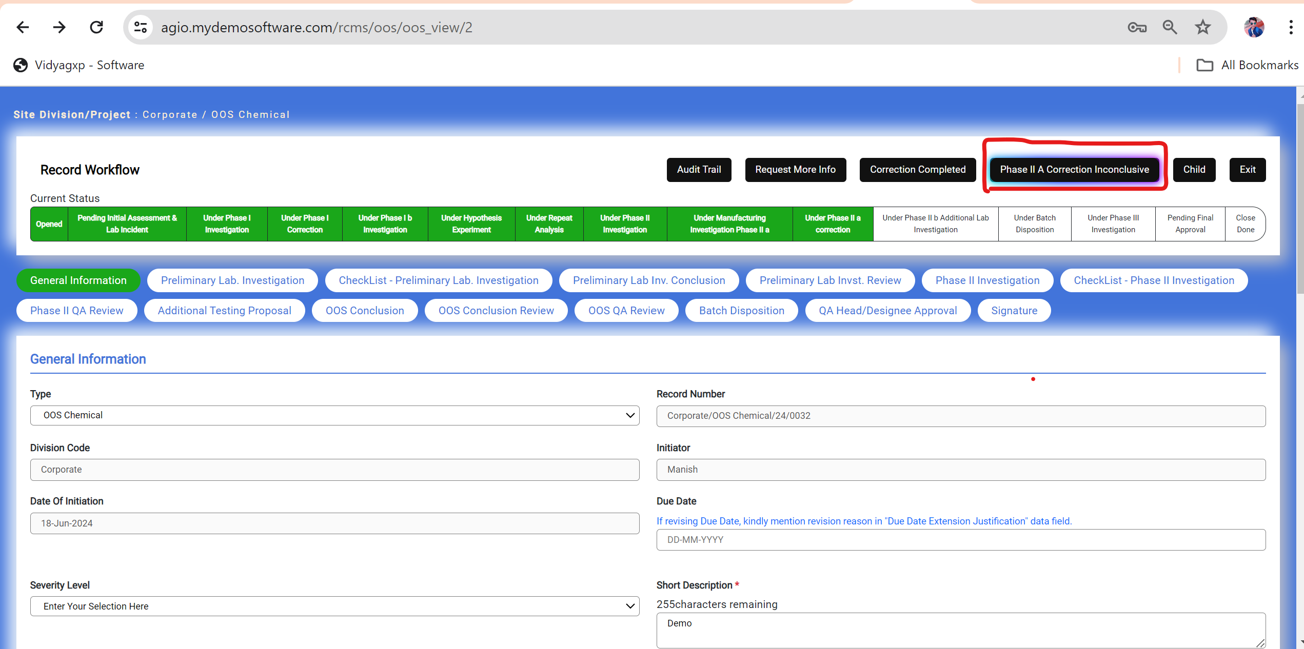

**Blank Page After Performing Activity.**

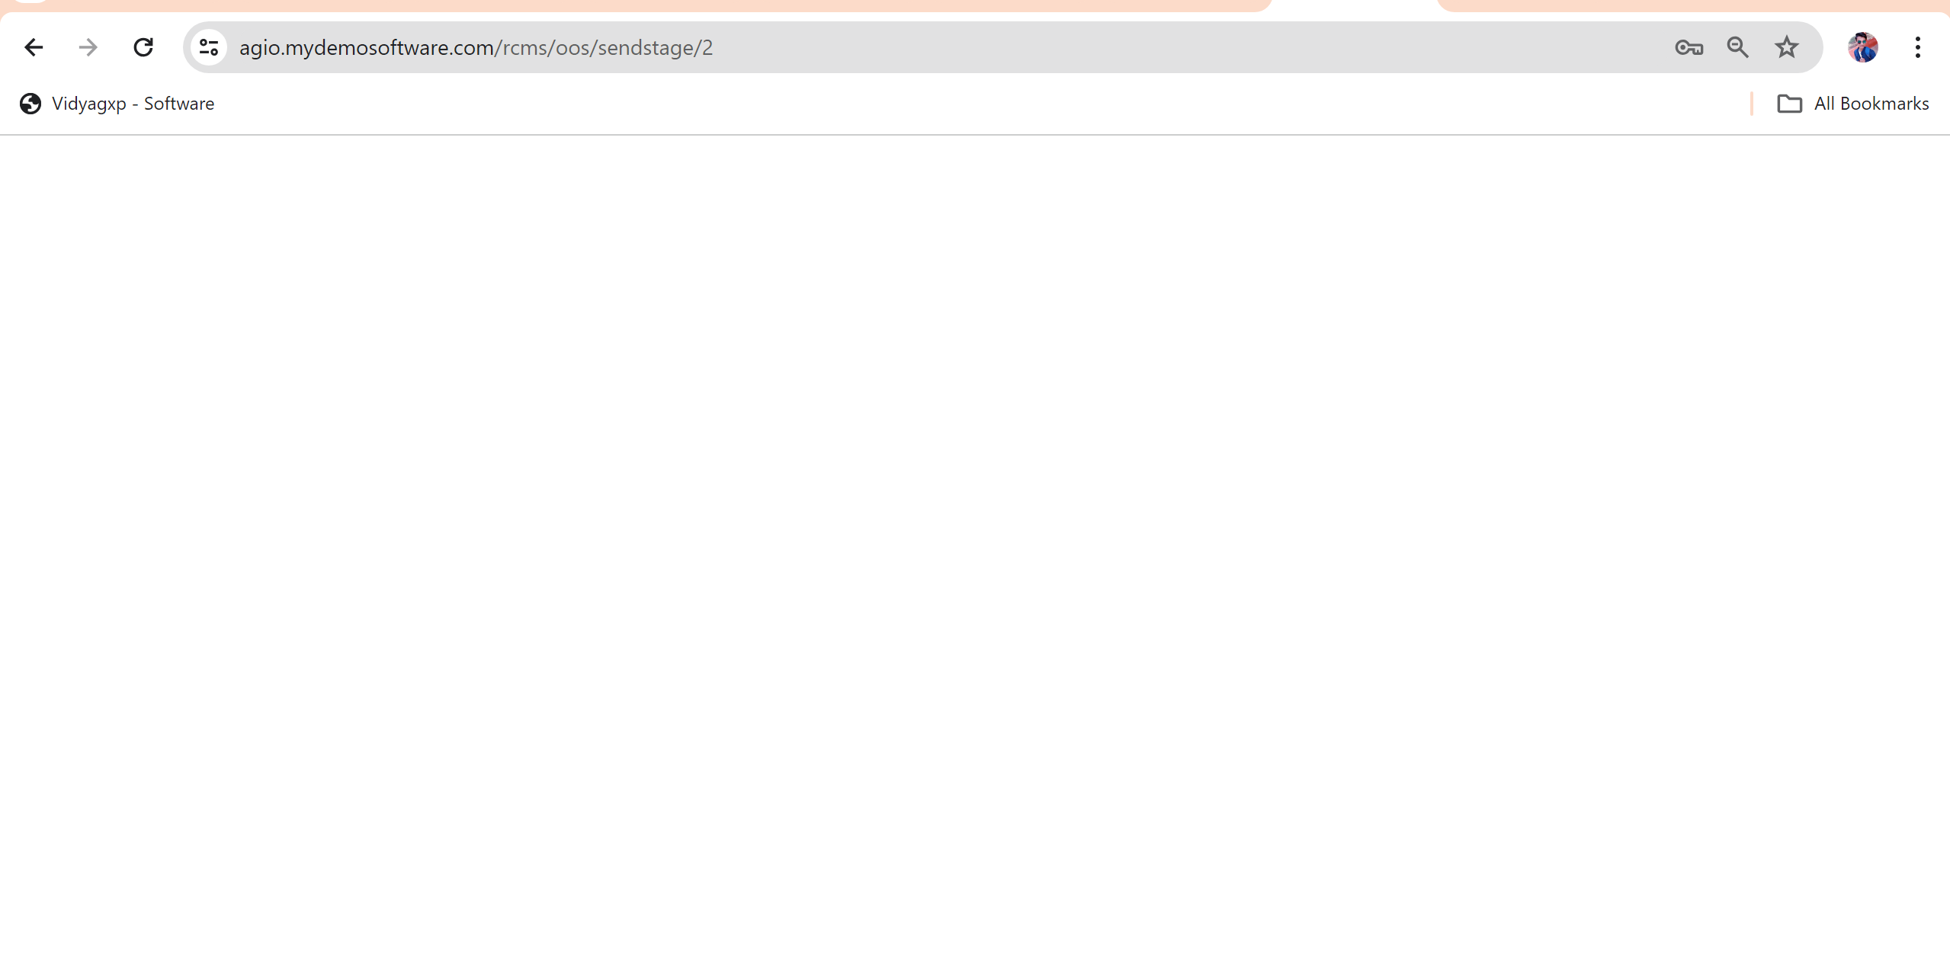

21. According to Workflow Send to under phase II a Correction Activity is missing in Pending Final Approval State.

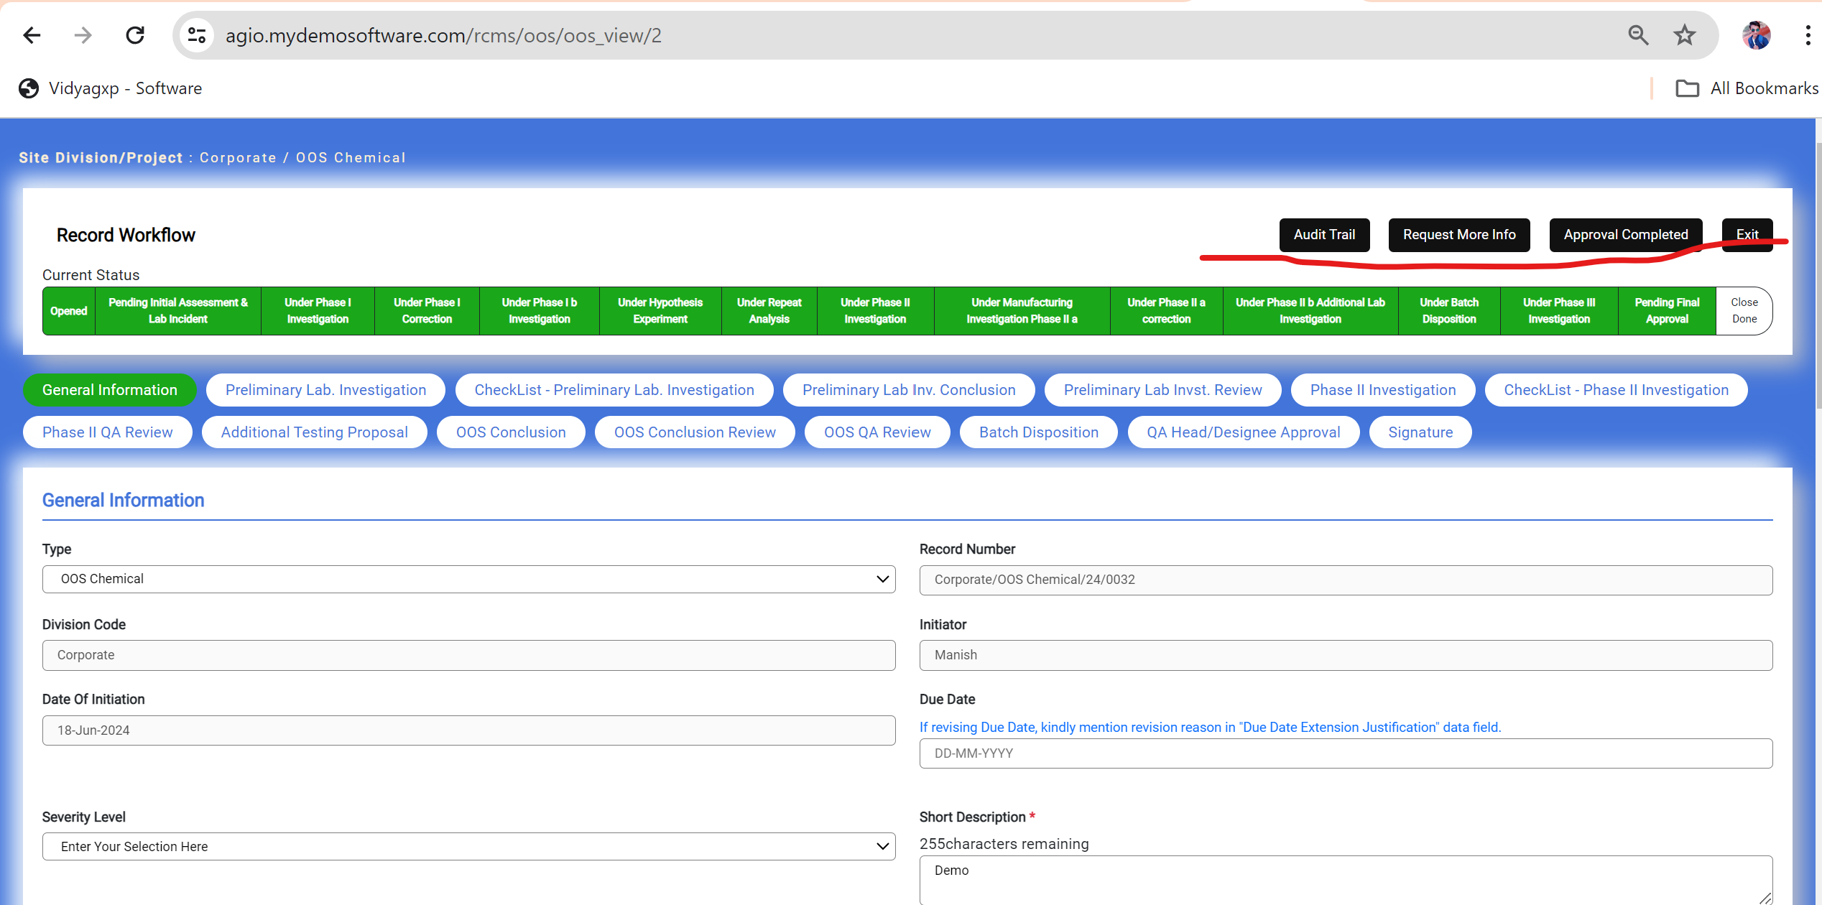

22. in Closed-Done State Data field should not editable. User cant edit data field in close-Done State.

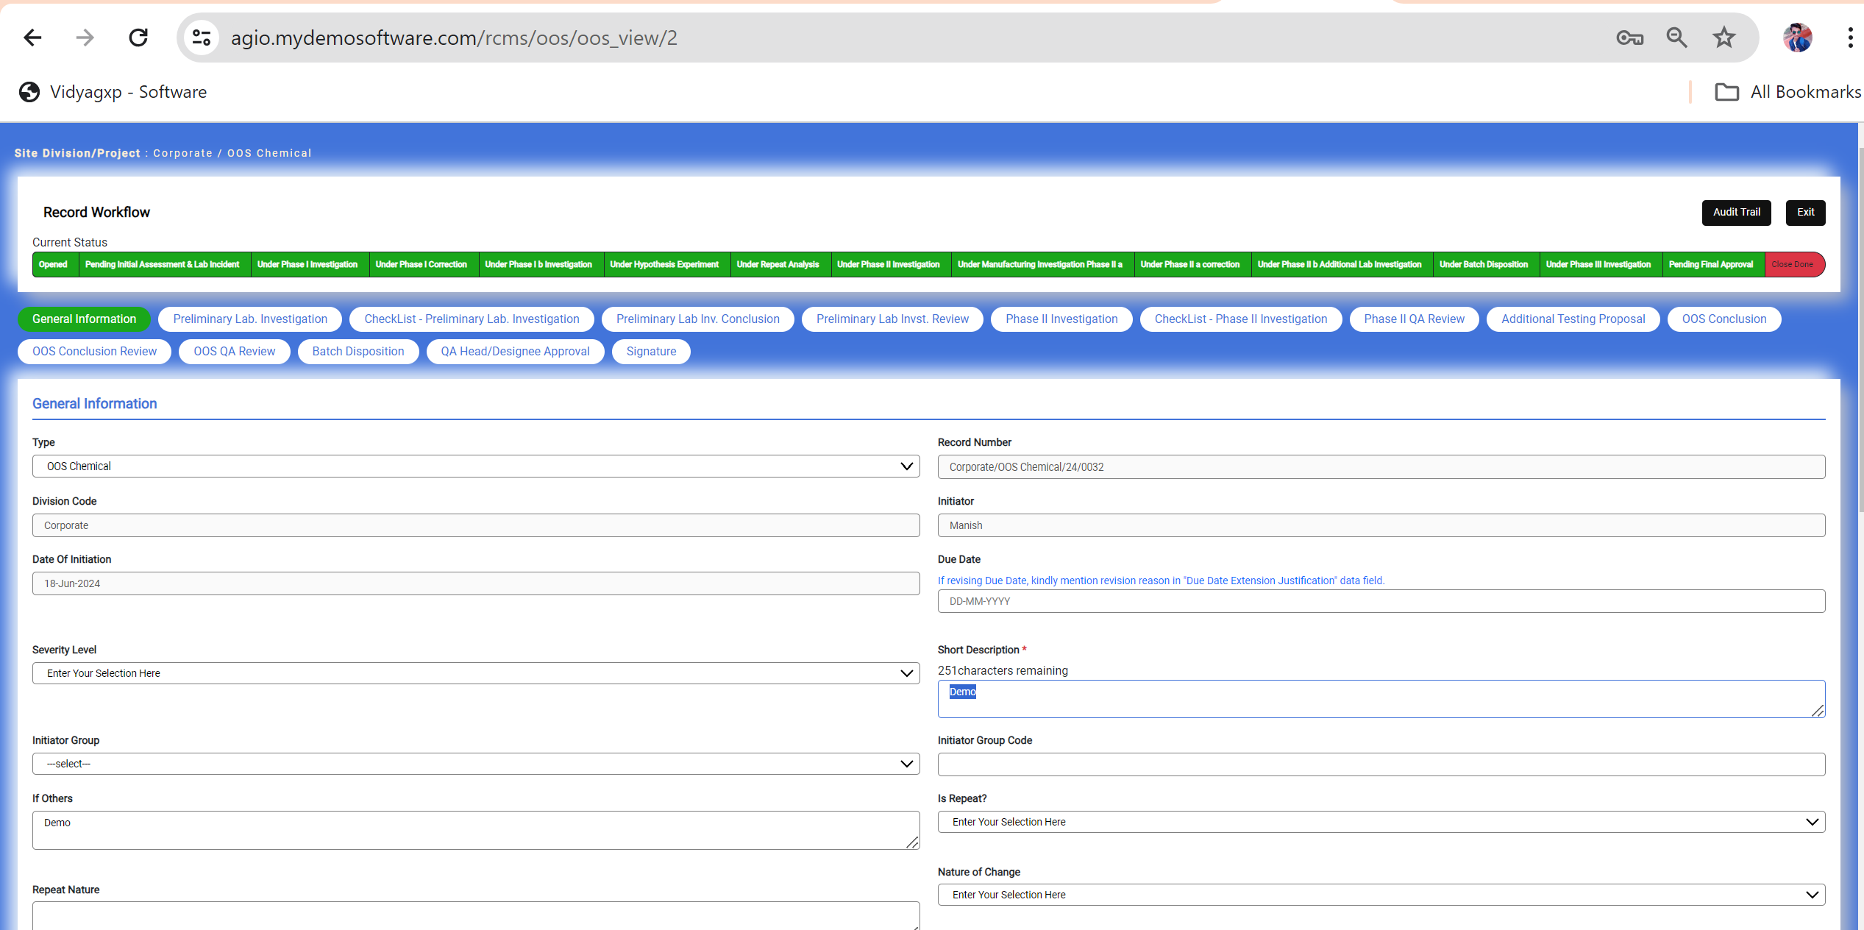

23. record number is wrong when I am generating single report form dashboard.

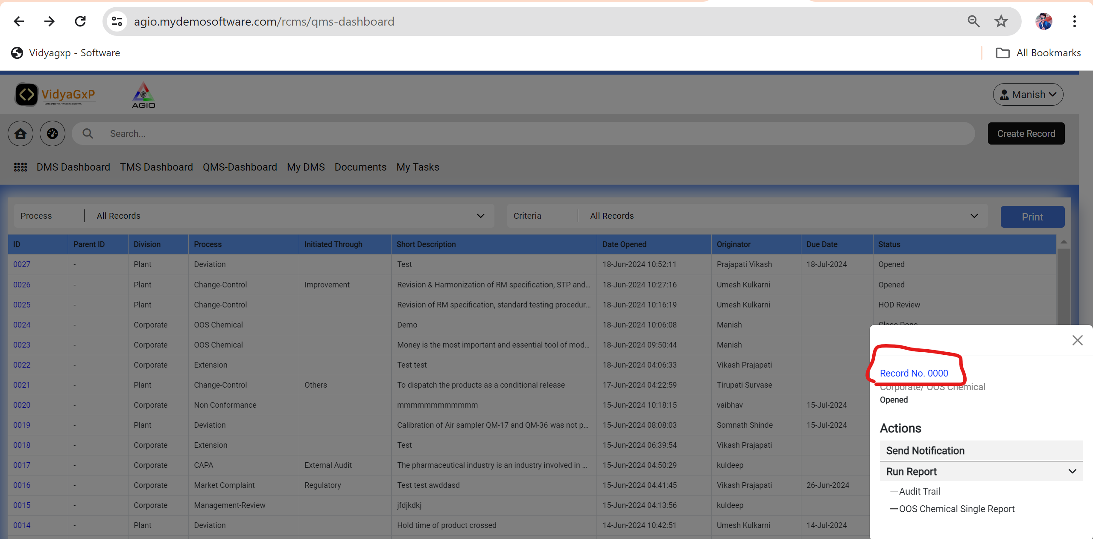

Audit Trail

1. Record creation are not show

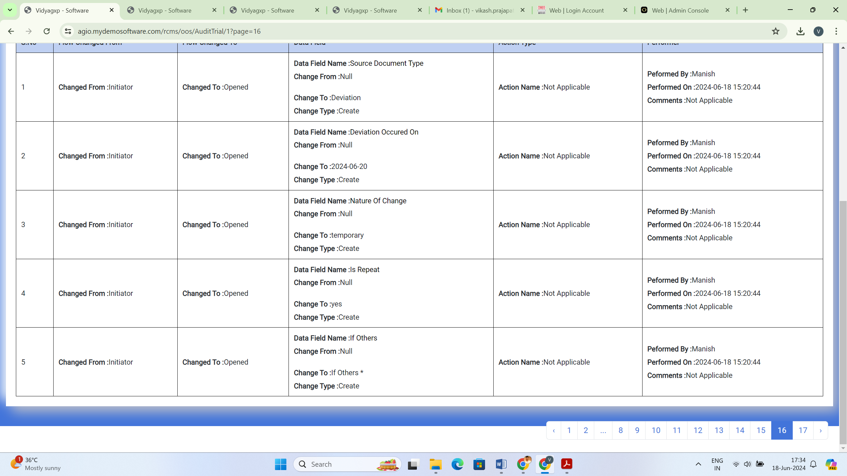

1. This Tab Fields are change but not save in audit trail

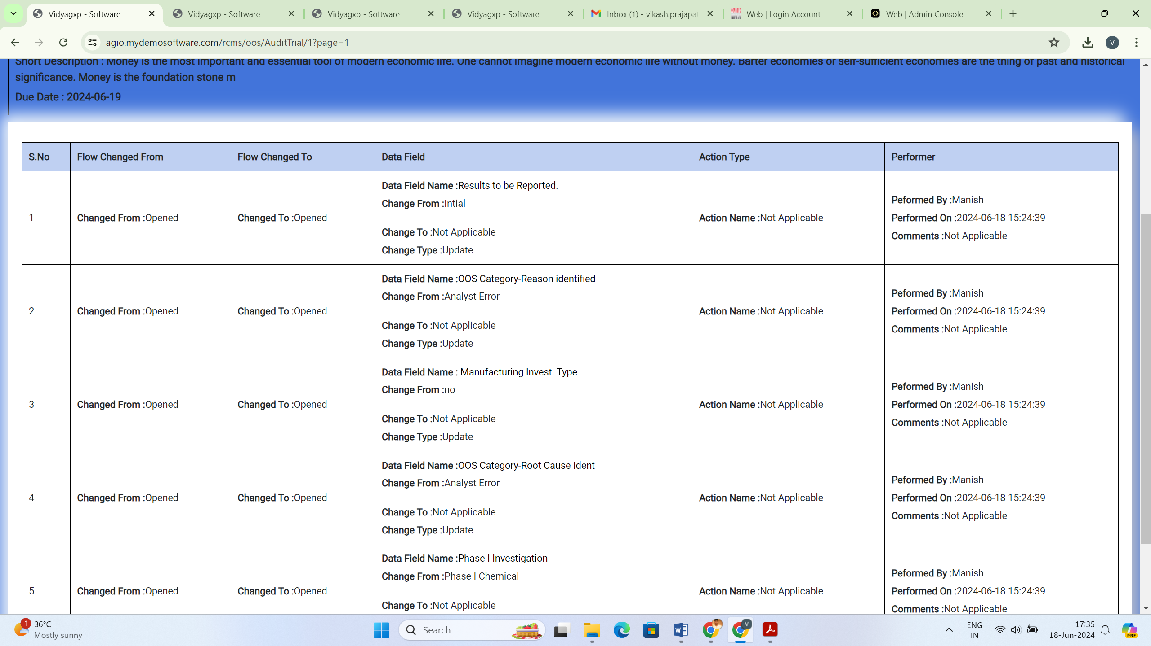

1. Change to change from are not show and Action

